**IT Spark Corporation -**

**A Career Services Enterprise**

*Submitted in fulfillment of the*

*Requirements of the award of the degree of*

**Bachelor of Technology**

*In*

**Information Technology**

By:

**Hargovind Singh (0831323108/IT2/2008)**

**Harjot Kaur (0841323108/IT2/2008)**

**Harpreet Kaur (1331323108/IT2/2008)**

**Inderpreet Kaur (0721323108/IT2/2008)**

**Daler Kaur (0871323108/IT2/2008)**

Under the guidance of

**Mr. P. S. Bedi**



**Department of Information Technology**

**Guru Tegh Bahadur Institute of Technology**

**Guru Gobind Singh Indraprastha University**

**Kashmere Gate,New Delhi**

**Year 2011-2012**

# DECLARATION

We hereby declare that our project entitled “**IT SPARK CORPORATION - A Career Services Enterprise”** has been developed only to be submitted as major project for partial fulfillment of award of degree of bachelor of technology in Information Technology. This project has not been submitted and/or used for fulfillment of any other degree or for any professional work.

Date:

 Hargovind Singh

(12/IT2/2008)

hargo.drums@gmail.com

Harjot Kaur

(13/IT2/2008)

harjotkaursaharan@gmail.com

Daler Kaur

(16/IT2/2008)

[dalerkr@gmail.com](mailto:dalerkr@gmail.com)

Inderpreet Kaur

(01/IT2/2008)

[kaur.inderpreet21@gmail.com](mailto:kaur.inderpreet21@gmail.com)

Harpreet Kaur

(31/IT2/2008)

harpreetkaur03@gmail.com

# CERTIFICATE

This is to certify that dissertation entitled **“IT SPARK CORPORATION”,** which is submitted by **Mr. Hargovind Singh, Ms. Harjot Kaur, Ms. Harpreet Kaur, Ms. Daler Kaur** and **Ms. Inderpreet Kaur** in partial fulfillment of the requirement for the award of the degree of Bachelor of Technology in **Information Technology**, Guru Tegh Bahadur Institute of Technology, New Delhi is an authentic record of the candidate’s own work carried out by them under our guidance. The matter embodied in this thesis is original and has not been submitted for the award of any other degree.

Mr. P.S. Bedi Mr. Ashish Bharadwaj

(Project Guide) (Head of the department)

(Information Technology)

Date:

# ACKNOWLEDGEMENT

We would like to express our great gratitude towards our supervisor, **Mr. P.S. Bedi** who has given us support and suggestions in framing this project. We also thank our laboratory teachers for giving productive suggestions to execute this project.

We are sincerely grateful to **Mr. Ashish Bharadwaj** for their earnest guidance and advice without which our project would have remained a fiction.

Date:

Hargovind Singh

(12/IT2/2008)

hargo.drums@gmail.com

Harjot Kaur

(13/IT2/2008)

harjotkaursaharan@gmail.com

Daler Kaur

(16/IT2/2008)

[dalerkr@gmail.com](mailto:dalerkr@gmail.com)

Inderpreet Kaur

(01/IT2/2008)

[kaur.inderpreet21@gmail.com](mailto:kaur.inderpreet21@gmail.com)

Harpreet Kaur

(31/IT2/2008)

harpreetkaur03@gmail.com

# CONTENT

DECLARATION 2

CERTIFICATE 3

ACKNOWLEDGEMENT 4

CONTENT 5

1.INTRODUCTION 7

2.ABSTRACT 8

3.OVERVIEW OF TECHNOLOGY USED 9

3.1 WHAT IS JAVA? 9

3.2 HISTORY 9

3.3 HOW DOES A JAVA PROGRAM GET EXECUTED? 10

3.4 J2EE 12

3.5 Oracle 10g Database & Application Server 15

3.6 JavaScript 17

3.7 JBOSS DEVELOPER STUDIO 18

3.8 DREAMWEAVER 19

4.SYSTEM ANALYSIS 20

4.1 DEFINITION 20

4.2 DESCRIPTION OF PRESENT SYSTEM 20

4.3 PROPOSED SYSTEM 20

4.4 FEASIBILITY STUDY 21

5.SYSTEM DESIGN 23

5.1 DEFINITION 23

5.2 OUTPUT DESIGN 23

5.3 INPUT DESIGN 24

5.4 LOGICAL DESIGN 24

5.5.1 CONTEXT DIAGRAM 25

5.5.2 DATA FLOW DIAGRAM 26

6.TABLE SPECIFICATION 31

7.SYSTEM SPECIFICATIONS 35

7.1 Hardware Specification 35

7.2 Software Specification 35

8. FUTURE SCOPE 36

9.CONCLUSION 37

10.BIBLIOGRAPHY 38

APPENDIX A: SOURCE CODE 39

APPENDIX B : SCREEN SHOTS 73

**CONFIGURING AND SETTING UP SERVER** 73

WEBAPP OUTPUT: 88

# 1.INTRODUCTION

This project *Online Recruitment System* is an online web application in which jobseekers can register themselves online and apply for job and attend the exam. Online Recruitment System provides online help to the users all over the world. Using web recruitment systems like recruitment webapps or jobsites also play a role in simplifying the recruitment process. Such webapps have facilities where prospective candidates can upload their CV’s and apply for jobs suited to them. Such sites also make it possible for recruiters and companies to post their staffing requirements and view profiles of interested candidates. Earlier recruitment was done manually and it was all at a time consuming work. Now it is all possible in a fraction of second. It is all done online without much time consuming. Today’s recruitment applications are designed to do a whole lot more than just reduce paperwork. They can make a significant contribution to a company’s marketing and sales activity. Recruitment webapps and software make possible for managers to access information that is crucial to managing their staff, which they can use for promotion decisions, payroll considerations and succession planning.

Online Recruitment System enables the users to have the typical examination facilities and features at their disposal. It resolves typical issues of manual examination processes and activities into a controlled and closely monitored work flow in the architecture of the application. This multi-platform solution brings in by default, the basic intelligence and immense possibilities for further extension of the application as required by the user. The system makes it friendly to distribute, share and manage the examination entities with higher efficiency and easiness. The objective of these webapps is to serve as a common meeting ground for jobseekers and employers, both locally and globally, where the candidates find their dream jobs and recruiters find the right candidate to fulfill their needs. These sites are specifically designed for those who seek the most demanding and challenging positions in their chosen field, with the most dynamic employers. Thousands of webapps compete for your attention-each has its own unique interface, URL and peculiarities.

A quick look at the overall trends in Online recruiting shows the rise in the importance of marketing the web site, online training, dawn of video interviews and emergence of professional Internet Recruiters. Online recruiting and online recruiting systems, with its emphasis on a more strategic decision making process is fast gaining ground as a popular outsourced function.

# 2.ABSTRACT

This project is aimed at developing a web-based and central recruitment Process system for the HR Group for a company. Some features of this system will be creating vacancies, storing application data, and Interview process initiation, Scheduling interviews, storing Interview results for the applicant and finally Hiring of the applicant. Reports may be required to be generated for the use of the HR group.

This project ‘*Online Recruitment System’* is an online webapp in which jobseekers can register themselves and then attend the exam. Based on the outcome of the exam the jobseekers will be short listed. For fresher, the exam will be conducted at some venue after short listing of the preliminary Aptitude Test. The details of the examination, venue & Date of the examination will be made available to them through the webapp.

Module in this project:

1. Administrator

2. Jobseekers

3. Company

Brief description on the modules:

1. Administrator: Administrator has the full authority over the webapp. He can view all the registered users and have the power to delete them. He can edit the web pages and update them. He can view all the company details also.

2. Jobseeker: A jobseeker can register himself. After registration, he will be directed to his homepage. Here he can update his profile, change password and see the examination details and all.

3. Company: A company can register itself, conduct online examination, approve or disapprove candidates attending examination and provides results about the selected candidates.

# 3.OVERVIEW OF TECHNOLOGY USED

## 3.1 WHAT IS JAVA?

Java Technology is both a programming language and a platform. Java is originally developed by James Gosling at Sun Microsystems (which is now a subsidiary of Oracle Corporation) and released in 1995 as a core component of Sun Microsystems' Java platform.Java applications are typically compiled to bytecode (class file) that can run on any Java Virtual Machine (JVM) regardless of computer architecture.It is intended to let application developers "write once, run anywhere"Java is currently one of the most popular programming languages in use, and is widely used from application software to web applications.

## 3.2 HISTORY

James Gosling, Mike Sheridan, and Patrick Naughton initiated the Java language project in June 1991. Java was originally designed for interactive television, but it was too advanced. The language was initially called Oak after an oak tree that stood outside Gosling's office; it went by the name Green later, and was later renamed Java, from a list of random words.Sun Microsystems released the first public implementation as Java 1.0 in 1995.

Versions Released…

Java = 1.0, 1.02, 1.1

Java2 = 1.2, 1.3, 1.4

Java 5.0 = 1.5 (code name = ‘Tiger’ release)

Java 6 = 1.6 (code name = ‘Dolphin’ release)

The Java Programming Language is a high level language that can be characterized by following buzzwords:

* Simple

* Object Oriented

* Secure

* Robust

* Distributive

* Dynamic

* Multithreaded

* Architecture neutral

* Portable

## 3.3 HOW DOES A JAVA PROGRAM GET EXECUTED?



##### Fig 3.1 Flow of data in program execution.

In the Java programming Language, all source code is written in plain text files ending with the .java extension. These source files are compiled into .class files by the javac compiler. A .class file does not contain code that is native to your processor; it instead contains *bytecodes,* the machine language of the Java Virtual Machine (JVM). The java launcher tool then runs your application with an instance of the Java Virtual Machine.

The Java platform differs from most other platforms in that it’s software-only platform that runs on top of other hardware-based platforms.

The Java platform has two categories :

* The Java Virtual Machine

* The Java Application Programming Interface (API)

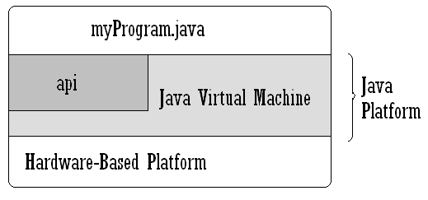

##### Fig 3.2 Java Platform

NOTE:

1. A Platform is the hardware or software environment in which a program runs. Like some Operating systems.

2. API includes all the classes and interfaces provided by Java (inbuilt).

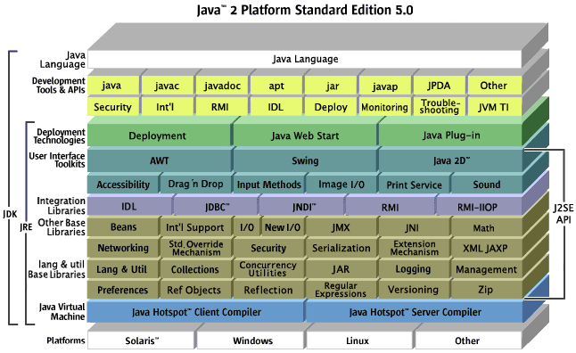

##### Fig 3.3 Java’s Platform & API

## 3.4 J2EE

**Architecture of J2EE**

Java 2 platform Enterpreise Edition provides a standard for developing multi-tier enterprise services.The economy and technology of today have intensified the need for faster ,more efficient and larger scale information management solutions.

The J2EE specifications satisfies these challenges;by providing a standard solution,speed programming model that improves developmant productivity,standardisation,standardises the platform for hosting enterprise edition and ensures portibility of developed applications with an entensive test suite.

J2EE architecture supports component based development of multi-tier enterprise applications.A J2EE application system typically supports the following tiers:

1. **Client Tier**

In the client tier ,web component ,such as servelets and JSP(Java Server Pages) or stand alone java applications provide a dynamic interface to the middle-tier.

1. **Middle Tier**

The server rier,or the middle=tier,enterprise beans and web services encapsulates reusable distributable buisness logic for the application.These server tier components are contained on a J2EE application server,which provides the platform for these components to perform actions and store data(s).

1. **Enterprise Data Tier**

In the data tier,the enterprise data is stored and persisted typically in arelational database environment.

NOTE:

* J2EE applications are comprised of components,containers and services.
* Components are application level components.
* Web components,such as servlets ans JSP provide dynamic responses to request from a web page.
* EJB components contain server side buisness logic for enterprise application.
* Web and EJB components contains host services that supports web and EJB modules

Browser

Application Client

**Application client container**

**J2EE Server**

Servlet

JSP Page

Web Container

Enterprise Bean

EJB Container

Enterprise Bean

Database

Client Machine

##### Fig 3.4 J2EE working

Sun Microsystems provides specifications for a comprehensive suite of technologies to solve large scale distributed system problems. This suite is the Java 2 Enterprise Edition, commonly known as J2EE. The J2EE Platform provides a component-based approach to the design, development, assembly, and deployment of enterprise applications.The J2EE platform is designed to provide server-side and client-side support for developing enterprise, multi-tier applications. Such applications are typically configured as a client tier to provide the user interface, one or more middle-tier modules that provide client services and business logic for an application, and backend enterprise information systems providing data management.

**J2EE APIs**

* JDBC – Java Database Connectivity
* RMI – IIOP - Remote Method Invocation over Internet Inter-Orb Protocol
* EJB – Enterprise Java Beans
* Java Servlet
* JSP – Java Server Pages
* JMS – Java Message Service
* JNDI – Java Naming and Directory Interface

##### Fig4J2EE Technologies

##### Fig 3.5 J2EE Container

J2EE applications are made up of components. A J2EE component is a self-contained functional software unit that is assembled into a J2EE application with its related classes and files and that communicates with other components. The J2EE specification defines the following J2EE components:

* The Component technologies – to hold the business logic. (JSP, Servlets and EJB)
* The Service technologies – to provide supported services to application components (JDBC, JTA, JNDI)
* The Communication technologies – transparent to appln programmer, provide the mechanism for communication among different parts of the application JavaMail, RMI-IIOP)
* J2EE does not specify the nature and structure of the runtime.
* J2EE Container – capability of the runtime to manage application components.
* J2EE APIs specifies the contract between the applications and the container.
* Different Containers – Web, EJB, Applet, application client.

The J2EE platform uses a multi-tiered distributed application model. Application logic is divided into components according to function, and the various application components that make up a J2EE application are installed on different machines depending on the tier in the multi-tiered J2EE environment to which the application component belongs

* Client-tier components run on Client machine.
* Web-tier components run on the J2EE server.
* Business-tier components run on the J2EE server.
* Enterprise information system (EIS)-tier software runs on the EIS server.

## 3.5 Oracle 10g Database & Application Server

**Oracle Weblogic Application Server Enterprise Edition**

Includes: Oracle Forms Services, Oracle Reports Services, TopLink, Portal, Discoverer Viewer, Discoverer Plus (Web Functionality), Identity Management (LDAP), Application Interconnect Toolkit, Workflow, Wireless Option, Personalization, and 5 JDeveloper Named User Plus licenses per Processor.

**Oracle Database 10g Enterprise Edition**

Includes: JServer Enterprise Edition, interMedia, Objects Option, Networking Kit, Objects for OLE, Advanced Replication Option, Distributed Option, Parallel Query Option, (including bitmap indexes and parallel bitmap-star query), SQL*Plus, Visual Information Retrieval and Workflow. Also included are: Advanced Backup & Recovery, Queuing, Advanced, Connection Manager & Pooling, 64-bit option, MPI, OCI, ODBC Driver, Enterprise Manager and Enterprise backup utility.

**Other Features of ORACLE**

|  |  |
| --- | --- |
| Client/Server (distributed processing) environments | To take full advantage of a given computer system or network, Oracle allows processing to be split between the database server and Client application programs. |
| Large databases and spaces management | Oracle supports the largest of databases, potentially 100 terabytes in size. To make efficient use of expensive hardware devices, it allows full control of space usage. |
| Many concurrent database users | Oracle supports large numbers of concurrent users executing a variety of database applications operating on the same data. It minimizes data contention and guarantees data concurrency. |
| High transaction processing performance | Oracle maintains the preceding features with a high degree of overall system performance. |
| High availability | Oracle can work 24x7 with no down time for quite a large amount of time. |
| Controlled availability | Oracle can selectively control the availability of data, at the database level and sub-database level. For example, an administrator can disallow use of a specific application so that the application’s data can be reloaded, without affecting other applications. |
| Database enforced integrity | Oracle enforces data integrity, “business rules” that dictate the standards for acceptable data. As a result, the costs of coding and managing checks in many database applications are eliminated. |
| Distributed Systems | For networked, distributed environments, Oracle combines the data physically located on different computers into one logical database that can be accessed by all network users. Distributed systems have the same degree of user transparency and data consistency as non-distributed systems, yet receive the advantages of local database management.  Oracle also offers the heterogeneous option that allows users to access data on some non-Oracle databases transparently. |
| Portability | Oracle software is ported to work under different operating systems. Applications developed for Oracle can be ported to any operating system with little or no modification. |
| Compatibility | Oracle software is compatible with industry standards, including most industry standard operating systems. Applications developed for Oracle can be used on virtually any system with little or no modification. |
| Connection ability | Oracle software allows different types of computers and operating systems to share information across network. |
| Replicated environment | Oracle software lets you replicate groups of tables and their supporting objects to multiple sites. Oracle supports replication of both data-and schema-level changes to these sites. Oracle’s flexible replication technology supports basic primary site replication as well as advanced dynamic and shared-ownership models. |

## 

##### Table 3.1 Features of Oracle

## 3.6 JavaScript

JavaScript was originally developed by Brendan Eich of Netscape under the name Mocha, later LiveScript, and finally renamed to JavaScript. The change of name from LiveScript to JavaScript roughly coincided with Netscape adding support for Java technology in its Netscape Navigator web browser. JavaScript was first introduced and deployed in the Netscape browser version 2.0B3 in December of 1995. When web developers talk about using JavaScript in Internet Explorer, they are actually using JScript. The choice of name proved to be a source of much confusion.As of 2006, the latest version of the language is JavaScript 1.7. The previous version 1.6 corresponded to ECMA-262 Edition 3 like JavaScript 1.5, except for Array extras, and Array and String generics. ECMAScript, in simple terms, is a standardized version of JavaScript. The ECMA-357 standard specifies E4X, a language extension dealing with XML.JavaScript is a prototype-based scripting language with a syntax loosely based on C. Like C, the language has no input or output constructs of its own. Where C relies on standard I/O libraries, a JavaScript engine relies on a host environment into which it is embedded. There are many such host environment applications, of which web technologies are the best-known examples. These are examined first.One major use of web-based JavaScript is to write functions that are embedded in or included from HTML pages and interact with the Document Object Model (DOM) of the page to perform tasks not possible in HTML alone. Some common examples of this usage follow.

## 3.7 JBOSS DEVELOPER STUDIO

JBoss Developer Studio Edition is a certified, open source development environment that includes all of the JBoss enterprise platforms and tooling: JBoss Enterprise Application Platform, JBoss SOA Platform, JBoss Enterprise Data Services Platform, and JBoss Portal Platform. It also provides certified, integrated tooling with JBoss Developer Studio, which integrates Eclipse, Eclipse Tooling, and JBoss Enterprise Platforms. It includes JBoss Operations Network, a management and monitoring tool, and access to OpenJDK. JBoss Developer Studio Portfolio Edition, with its integrated development environment, gives developers everything they need to build rich web applications, transactional enterprise applications, and SOA-based integration applications. They can use Hibernate, JBoss Seam, JBoss Portal, RichFaces, jBPM, Drools, and many other popular technologies. Developer Studio Portfolio Edition includes both certified tooling and runtime platforms. Developers can have confidence that their development environment and platforms are stable, upgradeable, deployable, and supportable. JBoss Developer Studio comes with one entitlement to Red Hat® Enterprise Linux® with built-in development tools and Red Hat Network Access for development purposes. JBoss Developer Studio Edition is available as a subscription for Windows, Linux, and Mac OS X for $99.

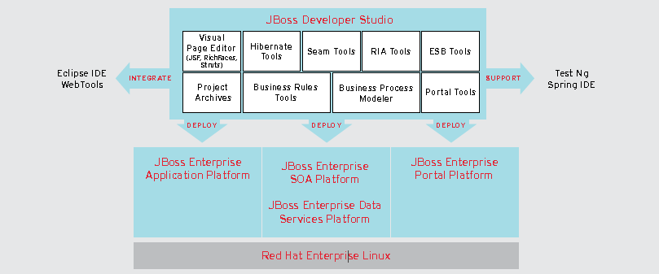

##### Fig 3.6 JBoss Developer Studio

## 3.8 DREAMWEAVER

Adobe Dreamweaver CS5.5 web design software provides an intuitive visual interface for making and editing HTML websites and mobile apps. Use fluid grid layout designed for cross-platform compatibility to create adaptive layouts. Review designs with Multiscreen Preview before publishing.

Adobe Dreamweaver (formerly Macromedia Dreamweaver) is a [proprietary](http://en.wikipedia.org/wiki/Proprietary_software) [web development](http://en.wikipedia.org/wiki/Web_development)[application](http://en.wikipedia.org/wiki/Application_software) originally created by [Macromedia](http://en.wikipedia.org/wiki/Macromedia). It is now developed by [Adobe Systems](http://en.wikipedia.org/wiki/Adobe_Systems), which acquired Macromedia in 2005. Dreamweaver is available for both [Mac](http://en.wikipedia.org/wiki/Mac_OS_X) and [Windows](http://en.wikipedia.org/wiki/Microsoft_Windows) [operating systems](http://en.wikipedia.org/wiki/Operating_system). Recent versions have incorporated support for [web](http://en.wikipedia.org/wiki/World_Wide_Web) technologies such as [CSS](http://en.wikipedia.org/wiki/Cascading_Style_Sheets), [JavaScript](http://en.wikipedia.org/wiki/JavaScript), and various [server-side scripting](http://en.wikipedia.org/wiki/Server-side_scripting)[languages](http://en.wikipedia.org/wiki/Programming_language) and [frameworks](http://en.wikipedia.org/wiki/Software_framework) including [ASP](http://en.wikipedia.org/wiki/Active_Server_Pages) (ASP JavaScript, ASP VBScript, ASP.NET C#, ASP.NET VB),[ColdFusion](http://en.wikipedia.org/wiki/ColdFusion), [Scriptlet](http://en.wikipedia.org/wiki/Scriptlet), and [PHP](http://en.wikipedia.org/wiki/PHP).

# 4.SYSTEM ANALYSIS

## 4.1 DEFINITION

System Analysis is the detailed study of the various operations performed by the system and their relationships within and outside the system. Analysis is the process of breaking something into its parts so that the whole may be understood. System analysis is concerned with becoming aware of the problem, identifying the relevant and most decisional variables, analyzing and synthesizing the various factors and determining an optional or at least a satisfactory solution. During this a problem is identified, alternate system solutions are studied and recommendations are made about committing the resources used to the system.

## 4.2 DESCRIPTION OF PRESENT SYSTEM

Presently recruitment is done manually. That is if a company or organization needs employees they make an announcement through newspaper. People who are eligible send application to the organization or company. From these applications they are called for interviews or tests. After tests company has to do short listing manually. From these shortlisted candidates, they are called for interviews. After interview short listed candidates are employed. So it’s all a time consuming procedure.

## 4.3 PROPOSED SYSTEM

Online Recruitment is aimed at developing a web-based and central recruitment Process system for the HR Group for a company. Some features of this system will be creating vacancies, storing application data, and Interview process initiation, Scheduling Interviews, Storing Interview results for the applicant and finally hiring of the applicant. This project *Online Recruitment System* is an online webapp in which jobseekers can register themselves and then attend the exam. Based on the outcome of the exam the jobseekers will be shortlisted. The details of the examination & Date of the examination will be made available to them through the webapp. People all around the world can apply and register. It has made all the process easy.

**ADVANTAGES**

Online Recruitment System enables the users to have the typical examination facilities and features at their disposal. It resolves typical issues of manual examination processes and activities into a controlled and closely monitored work flow in the architecture of the application. This multi-platform solution brings in by default, the basic intelligence and immense possibilities for further extension of the application as required by the user. The system makes it friendly to distribute, share and manage the examination entities with higher efficiency and easiness. It is a comprehensive resource for finding a job online.

## 4.4 FEASIBILITY STUDY

A feasibility analysis usually involves a thorough assessment of the operational (need), financial and technical aspects of a proposal. Feasibility study is the test of the system proposal made to identify whether the user needs may be satisfied using the current software and hardware technologies, whether the system will be cost effective from a business point of view and whether it can be developed with the given budgetary constraints. A feasibility study should be relatively cheap and done at the earliest possible time. Depending on the study, the decision is made whether to go head with a more detailed analysis.

When a new project is proposed, it normally goes through feasibility assessment. Feasibility study is carried out to determine whether the proposed system is possible to develop with available resources and what should be the cost consideration. Facts considered in the feasibility analysis were

* Technical Feasibility
* Economic Feasibility
* Behavioral Feasibility

**Technical Feasibility**

Technical feasibility includes whether the technology is available in the market for development and its availability. The assessment of technical feasibility must be based on an outline design of system requirements in terms of input, output, files, programs and procedures. This can be qualified in terms of volumes of data, trends, frequency of updating, cycles of activity etc, in order to give an introduction of technical system. Considering our project it is technical feasible. Online Recruiting and Online Recruitment Systems, with its emphasis on a more strategic decision making process is fast gaining ground as a popular outsourced function.

**Economic Feasibility**

This feasibility study present tangible and intangible benefits from the project by comparing the development and operational cost. The technique of cost benefit analysis is often used as a basis for assessing economic feasibility. This system needs some more initial investment than the existing system, but it can be justifiable that it will improve quality of service.

Thus feasibility study should center along the following points:

* Improvement resulting over the existing method in terms of accuracy, timeliness.
* Cost comparison
* Estimate on the life expectancy of the hardware.
* Overall objective.

Our project is economically feasible. It does not require much cost to be involved in the overall process. The overall objective is in easing out the recruitment processes.

**Behavioral / Operational Feasibility**

This analysis involves how it will work when it is installed and the assessment of political and managerial environment in which it is implemented. People are inherently resistant to change and computers have been known to facilitate change. The new proposed system is very much useful to the users and therefore it will accept broad audience from around the world.

# 5.SYSTEM DESIGN

## 5.1 DEFINITION

The most creative and challenging face of the system development is System Design. It provides the understanding and procedural details necessary for the logical and physical stages of development. In designing a new system, the system analyst must have a clear understanding of the objectives, which the design is aiming to fulfill. The first step is to determine how the output is to be produced and in what format. Second, input data and master files have to be designed to meet the requirements of the proposed output. The operational phases are handled through program construction and testing.

Design of the system can be defined as a process of applying various techniques and principles for the purpose of defining a device, a process or a system in sufficient detail to permit its physical realization. Thus system design is a solution to “how to” approach to the creation of a new system. This important phase provides the understanding and the procedural details necessary for implementing the system recommended in the feasibility study. The design step provides a data design, architectural design, and a procedural design.

## 5.2 OUTPUT DESIGN

In the output design, the emphasis is on producing a hard copy of the information requested or displaying the output on the CRT screen in a predetermined format. Two of the most output media today are printers and the screen. Most users now access their reports from either a hard copy or screen display. Computer’s output is the most important and direct source of information to the user, efficient, logical, output design should improve the systems relations with the user and help in decision-making.

As the outputs are the most important source of information to the user, better design should improve the systems relations and also should help in decision-making. The output device’s capability, print quality, response time requirements etc should also be considered, form design elaborates the way the output is presented and layout available for capturing information. It’s very helpful to produce the clear, accurate and speedy information for end users.

## 5.3 INPUT DESIGN

In the input design, user-originated inputs are converted into a computer-based system format. It also includes determining the record media, method of input, speed of capture and entry on to the screen. Online data entry accepts commands and data through a keyboard. The major approach to input design is the menu and the prompt design. In each alternative, the user’s options are predefined. The data flow diagram indicates logical data flow, data stores, source and destination. Input data are collected and organized into a group of similar data once identified input media are selected for processing.

In this software, importance is given to develop Graphical User Interface (GUI), which is an important factor in developing efficient and user friendly software. For inputting user data, attractive forms are designed. User can also select the desired options from the menu, which provides all possible facilities. Also the important input format is designed in such a way that accidental errors are avoided. The user has to input only just the minimum data required, which also helps in avoiding the errors that the users may make. Accurate designing of the input format is very important in developing efficient software. The goal of input design is to make entry as easy, logical and free from errors.

## 5.4 LOGICAL DESIGN

Logical data design is about the logically implied data. Each and every data in the form can be designed in such a manner to understand the meaning. Logical data designing should give a clear understanding & idea about the related data used to construct a form.

**Data flow diagram**

A Data Flow Diagram (DFD) is a diagram that describes the flow of data and the processes that change or transform data throughout a system. It’s a structured analysis and design tool that can be used for flowcharting in place of, or in association with, information oriented and process oriented system flowcharts. When analysts prepare the Data Flow Diagram, they specify the user needs at a level of detail that virtually determines the information flow into and out of the system and the required data resources. This network is constructed by using a set of symbols that do not imply a physical implementation. The Data Flow Diagram reviews the current physical system, prepares input and output specification, specifies the implementation plan etc.

Four basic symbols are used to construct data flow diagrams. They are symbols that represent data source, data flows, and data transformations and data storage. The points at which data are transformed are represented by enclosed figures, usually circles, which are called nodes.

### 5.5.1 CONTEXT DIAGRAM

Administrator

Database

Company

Candidate

### 5.5.2 DATA FLOW DIAGRAM

**Level 1: Admin**

Admin

Data store

Username Password

Category

If authenticated user

Category

TblLogin TblLogin

**Level 2: Company Management**

Admin

Update user

Status

TblLogin

TblCompany

**Level 3: User Management**

Admin

Update

Resume of

Registered users

User details

Experience details

Education details

TblLogin

TblCandidate

TblExperience

TblEducation

**Level 4: Company**

Company

Update Password

Update

Company details

Insert

Job details

Add

View

TblLogin

TblResult

TblCompany

TblJobDetails

TblQuestions

**Level 5: Candidate**

Jobseeker

Update

User details

Update

Password

Job details

TblCandidate

TblLogin

TblJobDetails

TblQuestion

TblResult

# 6.TABLE SPECIFICATION

**Table Name: Login**

|  |  |  |
| --- | --- | --- |
| **Fieldname** | **Data Type** | **Key** |
| Username | Varchar | - |
| Password | Varchar | - |
| Status | Varchar | - |

**Table Name: Details**

|  |  |  |
| --- | --- | --- |
| **Fieldname** | **Data Type** | **Key** |
| UserId | Varchar | Primary Key |
| Username | Varchar | - |
| Name | Varchar | - |
| Gender | Varchar | - |
| DateOfBirth | Varchar | - |
| CollegeName | Varchar | - |
| CollegePhone | Integer | - |
| CollegeEmail | Varchar | - |
| Branch | Varchar | - |
| Mark | Integer | - |
| Degree | Varchar | - |
| Email_id | Varchar | - |
| Telephone | Integer | - |
| Address | Varchar | -- |
| State | Varchar | - |
| Pincode | Integer | - |
| Category | Varchar | - |

**Table Name: Experienced**

|  |  |  |
| --- | --- | --- |
| **Fieldname** | **Data Type** | **Key** |
| Username | Varchar | - |
| ExpYears | Integer | - |
| Company | Varchar | - |
| Designation | Varchar | - |
| Salary | Integer | - |
| ComAddress | Varchar | - |

**Table Name: JobDetails**

|  |  |  |
| --- | --- | --- |
| **Fieldname** | **Data Type** | **Key** |
| JobId | Varchar | - |
| Post | Varchar | - |
| Criteria | Varchar | - |
| NoOfVacancies | Integer | - |
| Salary | Integer | - |
| LastDate | Varchar | - |

**Table Name: Exam**

|  |  |  |
| --- | --- | --- |
| **Fieldname** | **Data Type** | **Key** |
| JobID | Varchar | - |
| Post | Varchar | - |
| ExamID | Varchar | - |
| ExamName | Varchar | - |
| Cutoff | Varchar | - |

**Table Name: Question**

|  |  |  |
| --- | --- | --- |
| **Fieldname** | **Data Type** | **Key** |
| JobID | Varchar | Primary key |
| ExamID | Varchar | - |
| QuestionNo | Varchar | - |
| Question | Varchar | - |
| Option1 | Varchar | - |
| Option2 | Varchar | - |
| Option3 | Varchar | - |
| Option4 | Varchar | - |
| Answer | Varchar | - |

**Table Name: Com**

|  |  |  |
| --- | --- | --- |
| **Fieldname** | **Data Type** | **Key** |
| Cid | Varchar | Primary key |
| CName | Varchar | - |
| CAddress | Varchar | - |
| CPost | Varchar | - |
| CCriteria | Varchar | - |
| CUsername | Varchar | - |
| CEmail | Varchar | - |
| CContact | Integer | - |
| CCutoff | Float | - |

**Table Name: Result**

|  |  |  |
| --- | --- | --- |
| **Fieldname** | **Data Type** | **Key** |
| StudentID | Varchar | - |
| examID | Varchar | - |
| JobID | Varchar | - |
| mark | Integer | - |

**Table Name: Temp_Data**

|  |  |  |
| --- | --- | --- |
| **Fieldname** | **Data Type** | **Key** |
| StudentID | Varchar | - |
| QstNo | Varchar | - |
| Qst | Varchar | - |
| Ch1 | Varchar | - |
| Ch2 | Varchar | - |
| Ch3 | Varchar | - |
| Ch4 | Varchar | - |
| Ans | Varchar | - |

# 7.SYSTEM SPECIFICATIONS

## 7.1 Hardware Specification

CPU : INTEL CORE i3

PROCESSOR SPEED : 2 GHz

COPROCESSOR : BUILT IN

TOTAL RAM : 4 GB

HARD DISK : 500 GB

KEYBOARD : 105 KEYS

MOUSE : LOGITECH MOUSE

DISPLAY : SGVA COLOR

PRINTER : HP DESK JET

## 7.2 Software Specification

##### FRONT END : J2EE , HTML & CSS, JAVASCRIPT

BACK END : ORACLE 10g

DEVELOPMENT PLATFORM : JBOSS APPLICATION SERVER 6.0

DESIGNING PLATFORM : ADOBE DREAMWEAVER CS5.5

OPERATING SYSTEM : WINDOWS 7

APPLICATION SERVER : ORACLE WEB-LOGIC ENTERPRISE

EDITION 10.x

# 8. FUTURE SCOPE

Online recruiting and online recruitment systems, with its emphasis on a more strategic decision making process is fast gaining ground as a popular outsourced function. Most Online Recruiting sites deliver easy-to-use search capabilities, customer service and convenience. The immense power of web enabling crucial recruitment processes to convert them into online recruitment systems is a key factor in easing out the recruitment processes. Recruiting and staffing software makes data collection easier and tasks get completed quicker. The return on investment is immediate, simply because of the reduced time and increased ease of recruitment processes. E-Recruiting technology is skill-based with automated pre-screening features which is the next step in the evolution of online recruiting.

Corporate expenditures for these Online-recruiting services are anticipated to increase dramatically in the next few years as corporate end users upgrade their hiring methodologies, strategies and technologies for finding talent.

The three macro-economics trends that are seen as fuelling the growth of this industry are:

* Shorter employment tenures
* Shrinking labor pools
* Need for technology workers

In wake of the new and related trends, it is imperative for frequent upgrades to a company’s software or web applications to make it easier for clients and employees to address new business needs.

# 9.CONCLUSION

Now a day’s manual process of searching a job of the appropriate choice and searching the appropriate candidate for a specific job has become a huge task. And so for realizing the need of easy management of this process the web-app has been developed. It’s very easy to update and maintain information through this web-app. The main features of this site includes flexibility, easy to manipulate information’s, easy access searching, storage, reduce manual work in an efficient manner, a quick, convenient, reliable, timely and effective way to reach recruiting, search and employment professionals worldwide and most economical. The project could very well be enhanced further as per the requirements.

# 10.BIBLIOGRAPHY

**BOOKS**

1. Charles Hampfed(2000)’Instant Java Server Pages’ University of Toranto
2. Herbert Schildt(2000) ‘Java Complete Reference’ Tata McGrow Hill
3. John Zukowski(2000)’Master in Java2’ BPB Publications
4. Jamie Jaworsky ‘J2EE Bible ‘ Techmedia
5. Stefen Denniger ‘Enterprise JavaBeans 2.1’ Authors Press

# APPENDIX A: SOURCE CODE

//******************************************************************

// login.jsp

//******************************************************************

<!DOCTYPE html PUBLIC "-//W3C//DTD XHTML 1.1//EN" "http://www.w3.org/TR/xhtml11/DTD/xhtml11.dtd">

<html xmlns=*"http://www.w3.org/1999/xhtml"* xml:lang=*"en"* lang=*"en"*>

<head>

<meta http-equiv=*'X-UA-Compatible'* content=*'IE=EmulateIE7'* />

<meta http-equiv=*"Cache-Control"* content=*"no-cache, no-store, must-revalidate"*>

<meta http-equiv=*"Pragma"* content=*"no-cache"*>

<meta http-equiv=*"Expires"* content=*"0"*>

<title>Login - IT Spark CORPORATION</title>

<!--[if IE 7]>

<style>

p {

line-height:1.5;

padding-bottom:12px;

}

h1 {

font-size:20px;

font-weight:bold;

color:#333;

padding-bottom:0;

}

h2 {

font-size:14px;

font-weight:bold;

color:#333;

padding-bottom:0

}

</style>

<![endif]-->

<link rel=*'stylesheet'* href=*'http://cdn1.editmysite.com/editor/images/common/common.css?15'* type=*'text/css'* /><link rel=*'stylesheet'* type=*'text/css'* href=*'files/main_style.css?1319278360'* title=*'wsite-theme-css'* />

<style type=*'text/css'*>

*#wsite-content* **div***.paragraph***,** *#wsite-content* **p,** *#wsite-content* *.product-description***,** *.blog-sidebar* **div***.paragraph***,** *.blog-sidebar* **p,** *.wsite-form-field* **label,** *.wsite-form-field* **label** {}

*#wsite-content* **h2,** *#wsite-content* *.product-title***,** *.blog-sidebar* **h2**{}

*#wsite-title*{font-family:*Georgia !important*;font-size:*28px !important*;}

</style>

<script type=*'text/javascript'*><!--

**var** STATIC_BASE = 'http://cdn1.editmysite.com/';

**var** STYLE_PREFIX = 'wsite';

//-->

</script>

<script type=*'text/javascript'* src=*'http://cdn1.editmysite.com/libraries/prototype/1.7-custom/prototype.min.js'*></script>

<script type=*'text/javascript'* src=*'http://cdn1.editmysite.com/libraries/scriptaculous/1.9.0-custom/effects.min.js'*></script>

<script type=*'text/javascript'* src=*'http://cdn1.editmysite.com/editor/images/common/utilities.js?3'*></script>

<script type=*'text/javascript'* src=*'http://cdn1.editmysite.com/editor/images/common/lightbox202.js?9'*></script>

<script type=*'text/javascript'* src=*'http://cdn1.editmysite.com/editor/libraries/flyout_menus.js?13'*></script>

<script type=*'text/javascript'*><!--

**var** IS_ARCHIVE=1;

**function** initFlyouts(){initPublishedFlyoutMenus([{"id":"127291795384081010","title":"Home","url":"index.html"},{"id":"916005226383428698","title":"Login","url":"login.html"},{"id":"218932767564197161","title":"Candidate Registration","url":"candidate-registration.html"},{"id":"963802718424838957","title":"Company Registration","url":"company-registration.html"},{"id":"436242411310823612","title":"Contact Us","url":"contact-us.html"},{"id":"642540944578226134","title":"Discussion Forum","url":"discussion-forum.html"}],'916005226383428698',"<li class='wsite-nav-more'><a href='#'>more...<\/a><\/li>",'active',**false**)}

**if** (Prototype.Browser.IE) window.onload=initFlyouts; **else** document.observe('dom:loaded', initFlyouts);

//-->

</script>

</head>

<body class=*'wsite-page-login'*>

<div id=*"wrapper"*>

<div id=*"header"*>

<div id=*"sitename"*><span class=*'wsite-logo'*><table style='height:*70px*'><tr><td><a href=*'index.jsp'*><span id=*"wsite-title"*>IT Spark Corporation<br /></span></a></td></tr></table></span></div>

</div>

<div id=*"content-wrapper"*>

<div id=*"contents-body"*>

<div id=*"navigation"*>

<div id=*"nav-top"*></div>

<div id=*"navigation-links"*><ul><li id=*'pg127291795384081010'*><a href=*'index.jsp'*>Home</a></li><li id=*'active'*><a href=*'login.jsp'*>Login</a><div class=*'wsite-menu-wrap'* style='display:*none*'><ul class=*'wsite-menu'*><li id=*'wsite-nav-624430280190446915'*><a href=*'admin-home.html'*><span class=*'wsite-menu-title'*>Admin Home</span></a><div class=*'wsite-menu-wrap'* style='display:*none*'><ul class=*'wsite-menu'*></ul></div></li><li id=*'wsite-nav-290723617235183832'*><a href=*'company-home.html'*><span class=*'wsite-menu-title'*>Company Home</span></a><div class=*'wsite-menu-wrap'* style='display:*none*'><ul class=*'wsite-menu'*></ul></div></li><li id=*'wsite-nav-552960577565783351'*><a href=*'candidate-home.html'*><span class=*'wsite-menu-title'*>Candidate Home</span></a><div class=*'wsite-menu-wrap'* style='display:*none*'><ul class=*'wsite-menu'*></ul></div></li></ul></div></li><li id=*'pg218932767564197161'*><a href=*'candidate-registration.jsp'*>Candidate Registration</a></li><li id=*'pg963802718424838957'*><a href=*'company-registration.jsp'*>Company Registration</a></li><li id=*'pg436242411310823612'*><a href=*'contact-us.jsp'*>Contact Us</a></li><li id=*'pg642540944578226134'*><a href=*'discussion-forum.jsp'*>Discussion Forum</a></li></ul></div>

<div id=*"nav-bottom"*></div>

</div>

<div class=*"wsite-header"*></div>

<div id=*"contents"*><div id=*'wsite-content'* class=*'wsite-not-footer'*>

<div class=*'wsite-not-footer'*>

<h2 style=" text-align: *left*; ">Enter the details to login ..</h2>

<div class=*"paragraph editable-text"* style=" text-align: *left*; ">

<p><br />

</p>

<p>

<p>

<form name=*"login"* method=*"post"* action=*"savelogindata.jsp"*>

<div align=*"center"*>

<table cellpadding=*"0"* width=*"219"* height=*"230"* border=*"0"* align=*"center"*>

<tr valign=*"top"*>

<td height=*"36"* ><p align=*"center"* class=*"style10"*>Already a member??</p> </td>

</tr>

<tr>

<td width=*"209"* height=*"155"* >

<div align=*"center"*>

<p><strong>Enter Username </strong><br>

<input name=*"username"* type=*"text"* id=*"username"* />

</p>

</div>

<p align=*"center"*><strong>Enter Password

<input name=*"password"* type=*"password"* id=*"password"* />

</strong>

<label></label>

</p>

<div align=*"center"*>

<p>

<input type=*"submit"* name=*"Submit"* value=*"Login"* />

</p>

</div></td>

</tr>

</table>

</div></form>

<br />

<br />

</div>

<div ><div class=*"wsite-image-border-none "* style="padding-top:*10px*;padding-bottom:*10px*;margin-left:*0*;margin-right:*0*;text-align:*center*">

<a href=*'forgot-password.jsp'*>

<img src=*"uploads/9/1/5/8/9158082/5155673.jpg?286"* alt=*"Picture"* style="width:*auto*;max-width:*100%*" />

</a>

<div style="display:*block*;font-size:*90%*">

<p>Forgot Password? Click me!</p>

<p>&nbsp;</p>

<p>&nbsp;</p>

</div>

</div></div>

<div ><div style="height: *20px*; overflow: *hidden*; width: *100%*;"></div>

<hr class=*"styled-hr"* style="width:*100%*;"></hr>

<div style="height: *20px*; overflow: *hidden*; width: *100%*;"></div></div>

<div class=*"paragraph editable-text"* style=" text-align: *center*; ">Copyright&nbsp;&copy;&nbsp;2010-2011 IT Spark Corporation &nbsp;- All rights reserved &nbsp;<br /></div>

</div>

</div>

</div>

</div>

<div id=*"contents-bottom"*></div>

</div>

</div>

</body>

</html>

//******************************************************************

// re-login.jsp

//******************************************************************

<!DOCTYPE html PUBLIC "-//W3C//DTD XHTML 1.1//EN" "http://www.w3.org/TR/xhtml11/DTD/xhtml11.dtd">

<html xmlns=*"http://www.w3.org/1999/xhtml"* xml:lang=*"en"* lang=*"en"*>

<head>

<meta http-equiv=*'X-UA-Compatible'* content=*'IE=EmulateIE7'* />

<title>IT Spark CORPORATION </title>

<meta name=*'description'* content=*'Online recruitment system'* />

<!--[if IE 7]>

<style>

p {

line-height:1.5;

padding-bottom:12px;

}

h1 {

font-size:20px;

font-weight:bold;

color:#333;

padding-bottom:0;

}

h2 {

font-size:14px;

font-weight:bold;

color:#333;

padding-bottom:0

}

</style>

<![endif]-->

<link rel=*'stylesheet'* href=*'http://cdn1.editmysite.com/editor/images/common/common.css?15'* type=*'text/css'* />

<link rel=*'stylesheet'* type=*'text/css'* href=*'files/main_style.css?1319278360'* title=*'wsite-theme-css'* />

<style type=*'text/css'*>

*#wsite-content* **div***.paragraph***,** *#wsite-content* **p,** *#wsite-content* *.product-description***,** *.blog-sidebar* **div***.paragraph***,** *.blog-sidebar* **p,** *.wsite-form-field* **label,** *.wsite-form-field* **label** {}

*#wsite-content* **h2,** *#wsite-content* *.product-title***,** *.blog-sidebar* **h2**{}

*#wsite-title*{font-family:*Georgia !important*;font-size:*28px !important*;}

</style>

<link rel=*'stylesheet'* type=*'text/css'* href=*'http://cdn1.editmysite.com/editor/images/slideshow/slideshow.css?7'* />

<script type=*'text/javascript'*><!--

**var** STATIC_BASE = 'http://cdn1.editmysite.com/';

**var** STYLE_PREFIX = 'wsite';

//-->

</script>

<script type=*'text/javascript'* src=*'http://cdn1.editmysite.com/libraries/prototype/1.7-custom/prototype.min.js'*></script>

<script type=*'text/javascript'* src=*'http://cdn1.editmysite.com/libraries/scriptaculous/1.9.0-custom/effects.min.js'*></script>

<script type=*'text/javascript'* src=*'http://cdn1.editmysite.com/editor/images/common/utilities.js?3'*></script>

<script type=*'text/javascript'* src=*'http://cdn1.editmysite.com/editor/images/common/lightbox202.js?9'*></script>

<script type=*'text/javascript'* src=*'http://cdn1.editmysite.com/editor/libraries/flyout_menus.js?13'*></script>

<script type=*'text/javascript'* src=*'http://cdn1.editmysite.com/editor/libraries/slideshow.js?9'*></script>

<script type=*'text/javascript'*><!--

**var** IS_ARCHIVE=1;

**function** initFlyouts(){initPublishedFlyoutMenus([{"id":"127291795384081010","title":"Home","url":"index.html"},{"id":"916005226383428698","title":"Login","url":"login.html"},{"id":"218932767564197161","title":"Candidate Registration","url":"candidate-registration.html"},{"id":"963802718424838957","title":"Company Registration","url":"company-registration.html"},{"id":"436242411310823612","title":"Contact Us","url":"contact-us.html"},{"id":"642540944578226134","title":"Discussion Forum","url":"discussion-forum.html"}],'127291795384081010',"<li class='wsite-nav-more'><a href='#'>more...<\/a><\/li>",'active',**false**)}

**if** (Prototype.Browser.IE) window.onload=initFlyouts; **else** document.observe('dom:loaded', initFlyouts);

//-->

</script>

</head>

<body class=*'wsite-page-index'*>

<div id=*"wrapper"*>

<div id=*"header"*>

<div id=*"sitename"*><span class=*'wsite-logo'*><table style='height:*70px*'><tr><td><a href=*'index.jsp'*><span id=*"wsite-title"*>IT Spark Corporation<br /></span></a></td></tr></table></span></div>

</div>

<div id=*"content-wrapper"*>

<div id=*"contents-body"*>

<div id=*"navigation"*>

<div id=*"nav-bottom"*></div>

</div>

<div align=*"center"* class=*"wsite-header"*></div>

<p align=*"center"*>

You No more have access permissions..

</p>

<p align=*"center"*>You need to <a href=*"login3.jsp"*>Login </a> again . .</p>

<p align=*"center"*>&nbsp;</p>

</div>

<div id=*"contents-bottom"*></div>

</div>

</div>

</body>

</html>

//******************************************************************

//savecompanydata.jsp

//******************************************************************

<!DOCTYPE HTML PUBLIC "-//W3C//DTD HTML 4.01 Transitional//EN"

"http://www.w3.org/TR/html4/loose.dtd">

<%@page import=*"java.io.*,java.sql.*;"*%>

<%@page contentType=*"text/html"* pageEncoding=*"UTF-8"*%>

<html>

<head>

<meta http-equiv=*"Content-Type"* content=*"text/html; charset=UTF-8"*>

<title>i - World Corporation</title>

</head>

<link rel=*'stylesheet'* type=*'text/css'* href=*'files/main_style.css?1319278360'* title=*'wsite-theme-css'* />

<body >

<p>

<% **try**

{

// Class.forName("sun.jdbc.odbc.JdbcOdbcDriver");

//Connection con=DriverManager.getConnection("jdbc:odbc:OnlineExam");

//step 1: load & register the driver class

Class.forName("oracle.jdbc.driver.OracleDriver");

//step 2: Provide the connection string

Connection con = DriverManager.getConnection("jdbc:oracle:thin:@localhost:1521:XE","system","oracle");

//step 3: Get the statement

Statement st=con.createStatement();

Statement st2=con.createStatement();

String stat="c";

st2.executeUpdate("insert into Login values('"+request.getParameter("comusername")+"','"+request.getParameter("compassword")+"','"+stat+"')");

st.executeUpdate("insert into Com(CName,CAddress,CPost,CCriteria,CUsername,CEmail,CContact,CCutoff) values('"+request.getParameter("comname")+"','"+request.getParameter("comaddress")+"','"+request.getParameter("compost")+"','"+request.getParameter("comcriteria")+"','"+request.getParameter("comusername")+"','"+request.getParameter("comemail")+"','"+request.getParameter("comcontact")+"','"+request.getParameter("comcutoff")+"')");

st.close();

st2.close();

}

**catch**(Exception e)

{

out.println(e);

}

%>

</p>

<p>&nbsp;</p>

<p align = *"center"*> <font color=*"grey"* size=*"5"* ><br>

Registration Successfull!!!

<br>

Your account's Activation is under process ..

<br>

</font></p>

<font color=*"grey"* size=*"5"*>

<p align = *"center"* ><a href=*"login.jsp"*>Go Forward</a></p>

</font>

</body>

</html>

//******************************************************************//calcmark.jsp

//******************************************************************

<!DOCTYPE html PUBLIC "-//W3C//DTD XHTML 1.0 Transitional//EN" "http://www.w3.org/TR/xhtml1/DTD/xhtml1-transitional.dtd">

<html xmlns=*"http://www.w3.org/1999/xhtml"*>

<%@page contentType=*"text/html"* pageEncoding=*"UTF-8"* import=*"java.sql.*"* session=*"true"* %>

<head>

<meta http-equiv=*"Content-Type"* content=*"text/html; charset=utf-8"* />

<meta http-equiv=*"Cache-Control"* content=*"no-cache, no-store, must-revalidate"*>

<meta http-equiv=*"Pragma"* content=*"no-cache"*>

<meta http-equiv=*"Expires"* content=*"0"*>

<!--session management frwrding -->

<!--%

System.out.println("\n\n\n LoggedStatus>> " +session.getAttribute("LoggedStatus"));

if(session.getAttribute("LoggedStatus")==null){

System.out.println("\n\n Session has Expired ... need to relogin");

RequestDispatcher view = request.getRequestDispatcher("re-login.jsp");

view.forward(request, response);

}

%-->

<title>Untitled Document</title>

</head>

<link rel=*'stylesheet'* type=*'text/css'* href=*'files/main_style_candidate.css?1319277332'* title=*'wsite-theme-css'* />

<body>

</br>

<form id=*"form1"* name=*"form1"* method=*"post"* action=*"calcmark.jsp"*>

<p>&nbsp; </p>

<p>&nbsp;</p>

<p>

<input name=*"OK"* type=*"submit"* id=*"OK"* value=*"Submit"* />

</p>

</form>

</body>

</html>

<%

Statement st;

ResultSet rs;

String sql;

**int** mark = Integer.parseInt(session.getAttribute("mark").toString());

String ch = request.getParameter("ch");

String ans = request.getParameter("ans");

**int** qno = Integer.parseInt(request.getParameter("qno"));

**if** (ch != **null**) {

//out.println("Ch=" + ch + "<br> Ans=" + ans + "<br>Qno=" + qno + " Mark=" + mark);

ch = ch.trim();

ans = ans.trim();

**if** (ch.equalsIgnoreCase(ans)) {

mark++;

session.setAttribute("mark", mark);

}

}

**if** (qno < 10) {

response.sendRedirect("dispqst.jsp?qno=" + (qno + 1));

} **else** {

**try** {

String studentid = session.getAttribute("s1").toString();

sql = "delete from Temp_Data where StudID='" + studentid + "'";

// Class.forName("sun.jdbc.odbc.JdbcOdbcDriver");

// con = DriverManager.getConnection("jdbc:odbc:OnlineExam");

//step 1: load & register the driver class

Class.forName("oracle.jdbc.driver.OracleDriver");

//step 2: Provide the connection string

Connection con = DriverManager.getConnection("jdbc:oracle:thin:@localhost:1521:XE","system","oracle");

//step 3: Get the statement

st = con.createStatement();

st.executeUpdate(sql);

String examID = session.getAttribute("examid").toString();

String jobID = session.getAttribute("jobid").toString();

mark=Integer.parseInt(session.getAttribute("mark").toString());

sql="Insert into Result values('" + studentid + "','" + examID + "','" + jobID + "'," + mark + ")";

st.executeUpdate(sql);

response.sendRedirect("dispresult.jsp");

} **catch** (Exception ex) {

out.println(ex.toString());

}

}

%>

//******************************************************************

//candidate-registration.jsp

//******************************************************************

<!DOCTYPE html PUBLIC "-//W3C//DTD XHTML 1.0 Transitional//EN" "http://www.w3.org/TR/xhtml1/DTD/xhtml1-transitional.dtd">

<html xmlns=*"http://www.w3.org/1999/xhtml"*>

<%@page contentType=*"text/html"* pageEncoding=*"UTF-8"* import=*"java.sql.*"* session=*"true"* %>

<head>

<meta http-equiv=*"Content-Type"* content=*"text/html; charset=utf-8"* />

<meta http-equiv=*"Cache-Control"* content=*"no-cache, no-store, must-revalidate"*>

<meta http-equiv=*"Pragma"* content=*"no-cache"*>

<meta http-equiv=*"Expires"* content=*"0"*>

<!--session management frwrding -->

<!--%

System.out.println("\n\n\n LoggedStatus>> " +session.getAttribute("LoggedStatus"));

if(session.getAttribute("LoggedStatus")==null){

System.out.println("\n\n Session has Expired ... need to relogin");

RequestDispatcher view = request.getRequestDispatcher("re-login.jsp");

view.forward(request, response);

}

%-->

<title>Untitled Document</title>

</head>

<link rel=*'stylesheet'* type=*'text/css'* href=*'files/main_style_candidate.css?1319277332'* title=*'wsite-theme-css'* />

<body>

</br>

<form id=*"form1"* name=*"form1"* method=*"post"* action=*"calcmark.jsp"*>

<p>&nbsp; </p>

<p>&nbsp;</p>

<p>

<input name=*"OK"* type=*"submit"* id=*"OK"* value=*"Submit"* />

</p>

</form>

</body>

</html>

<%

Statement st;

ResultSet rs;

String sql;

**int** mark = Integer.parseInt(session.getAttribute("mark").toString());

String ch = request.getParameter("ch");

String ans = request.getParameter("ans");

**int** qno = Integer.parseInt(request.getParameter("qno"));

**if** (ch != **null**) {

//out.println("Ch=" + ch + "<br> Ans=" + ans + "<br>Qno=" + qno + " Mark=" + mark);

ch = ch.trim();

ans = ans.trim();

**if** (ch.equalsIgnoreCase(ans)) {

mark++;

session.setAttribute("mark", mark);

}

}

**if** (qno < 10) {

response.sendRedirect("dispqst.jsp?qno=" + (qno + 1));

} **else** {

**try** {

String studentid = session.getAttribute("s1").toString();

sql = "delete from Temp_Data where StudID='" + studentid + "'";

// Class.forName("sun.jdbc.odbc.JdbcOdbcDriver");

// con = DriverManager.getConnection("jdbc:odbc:OnlineExam");

//step 1: load & register the driver class

Class.forName("oracle.jdbc.driver.OracleDriver");

//step 2: Provide the connection string

Connection con = DriverManager.getConnection("jdbc:oracle:thin:@localhost:1521:XE","system","oracle");

//step 3: Get the statement

st = con.createStatement();

st.executeUpdate(sql);

String examID = session.getAttribute("examid").toString();

String jobID = session.getAttribute("jobid").toString();

mark=Integer.parseInt(session.getAttribute("mark").toString());

sql="Insert into Result values('" + studentid + "','" + examID + "','" + jobID + "'," + mark + ")";

st.executeUpdate(sql);

response.sendRedirect("dispresult.jsp");

} **catch** (Exception ex) {

out.println(ex.toString());

}

}

%>

//******************************************************************

//savelogindata.jsp

//******************************************************************

<!DOCTYPE html PUBLIC "-//W3C//DTD XHTML 1.1//EN" "http://www.w3.org/TR/xhtml11/DTD/xhtml11.dtd">

<html xmlns=*"http://www.w3.org/1999/xhtml"* xml:lang=*"en"* lang=*"en"*>

<%@page import=*"java.io.*,java.sql.*"*%>

<%@page contentType=*"text/html"* pageEncoding=*"UTF-8"*%>

<head>

<meta http-equiv=*"Content-Type"* content=*"text/html; charset=UTF-8"*>

<title>IT Spark Corporation</title>

</head>

<link rel=*'stylesheet'* type=*'text/css'* href=*'files/main_style.css?1319278360'* title=*'wsite-theme-css'* />

<body>

<% **try** {

System.out.println("\n\n\n all going right till now....");

session = request.getSession(**false**);

**if**(session ==**null**){

System.out.println("No session was available...\n making one...");

session = request.getSession();

}**else**{

System.out.println("\n there was a session ..!!");

}

String s1 = request.getParameter("username");

String s2 = request.getParameter("password");

session.setAttribute("s1", s1);

session.setAttribute("s2", s2);

//means a user is going to be logged in

session.setAttribute("LoggedStatus", **true**);

System.out.println("\n\n\n LoggedStatus>> " +session.getAttribute("LoggedStatus"));

// main DB code

//step 1: load & register the driver class

Class.forName("oracle.jdbc.driver.OracleDriver");

//step 2: Provide the connection string

Connection conn = DriverManager.getConnection("jdbc:oracle:thin:@localhost:1521:XE","system","oracle");

//step 3: Get the statement

//Statement stmt = conn.createStatement();

//step 4: perform d curd operations

// Class.forName("sun.jdbc.odbc.JdbcOdbcDriver");

// Connection conn = DriverManager.getConnection("jdbc:odbc:OnlineExam");

Statement st = conn.createStatement();

Statement st2 = conn.createStatement();

String stat = "";

ResultSet rs;

/*

System.out.println("============ TESTING if got connected to 10g DB==========");

rs = stmt.executeQuery("select * from emp");

while(rs.next()){

System.out.println(rs.getString(1)+" "+rs.getInt(2));

}

*/

System.out.println("");

rs = st.executeQuery("select * from Login where Username='" + s1 + "' and Password='" + s2 + "'");

%>

<!-- <input type= "hidden" name="id" value ="<%=s1%>">

<input type= "hidden" name="pass" value ="<%=s2%>">-->

<%

**while** (rs.next()) {

stat = rs.getString("status");

} //while

**if** (stat.equals("s")) {

response.sendRedirect("candidate-console.jsp");

} **else** **if** (stat.equals("c")) {

response.sendRedirect("company-console.jsp");

} **else** **if** (stat.equals("a")) {

response.sendRedirect("admin-console.jsp");

} **else** {

response.sendRedirect("login2.jsp");

}

}//try

**catch** (Exception e) {

out.println(e);

}

%>

<!-- <input type="hidden" name = "hid" value="<%request.getParameter("username");%>" -->

</body>

</html>

//******************************************************************

//ExamConditions.jsp

//******************************************************************

<!DOCTYPE html PUBLIC "-//W3C//DTD XHTML 1.1//EN" "http://www.w3.org/TR/xhtml11/DTD/xhtml11.dtd">

<html xmlns=*"http://www.w3.org/1999/xhtml"* xml:lang=*"en"* lang=*"en"*>

<%@page import=*"java.io.*,java.sql.*"*%>

<%@page contentType=*"text/html"* pageEncoding=*"UTF-8"*%>

<head>

<meta http-equiv=*"Content-Type"* content=*"text/html; charset=UTF-8"*>

<title>IT Spark Corporation</title>

</head>

<link rel=*'stylesheet'* type=*'text/css'* href=*'files/main_style.css?1319278360'* title=*'wsite-theme-css'* />

<body>

<% **try** {

System.out.println("\n\n\n all going right till now....");

session = request.getSession(**false**);

**if**(session ==**null**){

System.out.println("No session was available...\n making one...");

session = request.getSession();

}**else**{

System.out.println("\n there was a session ..!!");

}

String s1 = request.getParameter("username");

String s2 = request.getParameter("password");

session.setAttribute("s1", s1);

session.setAttribute("s2", s2);

//means a user is going to be logged in

session.setAttribute("LoggedStatus", **true**);

System.out.println("\n\n\n LoggedStatus>> " +session.getAttribute("LoggedStatus"));

// main DB code

//step 1: load & register the driver class

Class.forName("oracle.jdbc.driver.OracleDriver");

//step 2: Provide the connection string

Connection conn = DriverManager.getConnection("jdbc:oracle:thin:@localhost:1521:XE","system","oracle");

//step 3: Get the statement

//Statement stmt = conn.createStatement();

//step 4: perform d curd operations

// Class.forName("sun.jdbc.odbc.JdbcOdbcDriver");

// Connection conn = DriverManager.getConnection("jdbc:odbc:OnlineExam");

Statement st = conn.createStatement();

Statement st2 = conn.createStatement();

String stat = "";

ResultSet rs;

/*

System.out.println("============ TESTING if got connected to 10g DB==========");

rs = stmt.executeQuery("select * from emp");

while(rs.next()){

System.out.println(rs.getString(1)+" "+rs.getInt(2));

}

*/

System.out.println("");

rs = st.executeQuery("select * from Login where Username='" + s1 + "' and Password='" + s2 + "'");

%>

<!-- <input type= "hidden" name="id" value ="<%=s1%>">

<input type= "hidden" name="pass" value ="<%=s2%>">-->

<%

**while** (rs.next()) {

stat = rs.getString("status");

} //while

**if** (stat.equals("s")) {

response.sendRedirect("candidate-console.jsp");

} **else** **if** (stat.equals("c")) {

response.sendRedirect("company-console.jsp");

} **else** **if** (stat.equals("a")) {

response.sendRedirect("admin-console.jsp");

} **else** {

response.sendRedirect("login2.jsp");

}

}//try

**catch** (Exception e) {

out.println(e);

}

%>

<!-- <input type="hidden" name = "hid" value="<%request.getParameter("username");%>" -->

</body>

</html>

//******************************************************************

//ExamConduct.jsp

//******************************************************************

<!DOCTYPE html PUBLIC "-//W3C//DTD XHTML 1.1//EN" "http://www.w3.org/TR/xhtml11/DTD/xhtml11.dtd">

<html xmlns=*"http://www.w3.org/1999/xhtml"*>

<%@page import=*"java.io.*,java.sql.*;"*session=*"true"*%>

<%@page contentType=*"text/html"* pageEncoding=*"UTF-8"*%>

<%

Connection con = **null**;

Statement st = **null**, st2 = **null**;

ResultSet rs = **null**;

String sql = **null**;

**try** {

Class.forName("sun.jdbc.odbc.JdbcOdbcDriver");

con = DriverManager.getConnection("jdbc:odbc:OnlineExam");

st = con.createStatement();

} **catch** (Exception ex) {

out.println("Error: " + ex.toString());

}

%>

<head>

<meta http-equiv=*"Content-Type"* content=*"text/html; charset=UTF-8"*>

<title>Online Exam</title>

<link rel=*'stylesheet'* type=*'text/css'* href=*'files/main_style_candidate.css?1319277332'* title=*'wsite-theme-css'* />

</head>

<body style="margin:*0px*" >

</br>

<p>&nbsp;</p>

<p>&nbsp;</p>

<p>&nbsp;</p>

<p>&nbsp;</p>

<table cellpadding=*"0"* width=*"100%"* border=*"0"* >

<tr>

<td width=*"961"* valign=*"top"*>

<table cellpadding=*"0"* width=*"304"* height=*"243"* border=*"0"* align=*"center"*>

<tr>

<td colspan=*"2"*><div align=*"center"* class=*"style1"*>

<p>Exam</p>

<p>&nbsp;</p>

</div></td>

</tr>

<tr>

<%

String jid = request.getParameter("jobid");

**try** {

**if** (jid == **null**) {

%>

<form name=*"exam1"* action =*"ExamConduct.jsp"*>

<td width=*"167"* height=*"42"*><span class=*"style7"*>Select a JobID </span></td>

<td width=*"112"*>

<select name=*"jobid"*>

<%

rs = st.executeQuery("select * from JobDetails");

String s1 = **null**;

// String s2=null;

**while** (rs.next()) {

s1 = rs.getString("JobId");

// s2=rs.getString("Post");

out.println("<option value='" + s1 + "'>" + s1 + "</option>");

}//while

%>

</select>

</td>

<tr><td> <div align=*"center"*>

<input type=*"submit"* value=*"OK "*>

</div></td></tr>

</form>

<%

}//if

**else** {

jid = request.getParameter("jobid");

sql = "select Post from Exam where JobID='" + jid + "'";

rs = st.executeQuery(sql);

String post = **null**;

**if** (rs.next()) {

post = rs.getString("Post");

}

rs.close();

%> <form name=*"examSelection"* action =*"11.jsp"*>

<tr>

<td><span class=*"style7"*>Post Name :</span></td>

<td><%=post%></td>

<td width=*"11"*>&nbsp;</td>

</tr>

<tr>

<td height=*"30"* class=*"style7"*>&nbsp;</td>

<td>&nbsp;</td>

<td>&nbsp;</td>

</tr>

<tr>

<td height=*"30"* class=*"style7"*>Select an Exam</td>

<td><select name=*"examid"*>

<%

sql = "select ExamID,ExamName from Exam where JobID='" + jid + "'";

rs = st.executeQuery(sql);

String exname = **null**;

String exid = **null**;

**while** (rs.next()) {

exid = rs.getString("ExamID");

exname = rs.getString("ExamName");

out.println("<option value='" + exid + "'>" + exname + "</option>");

}

%>

</select>

</td>

<td>&nbsp;</td>

</tr>

<tr>

<td class=*"style7"*><div align=*"center"*>

<input type=*"submit"* value=*"OK "*>

</div></td>

</tr>

</form>

</table>

<p>&nbsp;</p>

<%

session.setAttribute("jobid", request.getParameter("jobid"));

session.setAttribute("post", post);

}//else

}//try

**catch** (Exception e) {

out.println(e);

}

%>

</td>

</tr>

</table>

</body>

</html>

//******************************************************************

//company-registration.jsp

//******************************************************************

<!DOCTYPE html PUBLIC "-//W3C//DTD XHTML 1.1//EN" "http://www.w3.org/TR/xhtml11/DTD/xhtml11.dtd">

<html xmlns=*"http://www.w3.org/1999/xhtml"* xml:lang=*"en"* lang=*"en"*>

<head>

<%@page import=*"java.io.*"* %>

<%@page import=*"java.sql.*"* %>

<%@page contentType=*"text/html"* pageEncoding=*"UTF-8"* session=*"true"*%>

<meta http-equiv=*'X-UA-Compatible'* content=*'IE=EmulateIE7'* />

<title>Company Registration - IT Spark CORPORATION</title>

<!--[if IE 7]>

<style>

p {

line-height:1.5;

padding-bottom:12px;

}

h1 {

font-size:20px;

font-weight:bold;

color:#333;

padding-bottom:0;

}

h2 {

font-size:14px;

font-weight:bold;

color:#333;

padding-bottom:0

}

</style>

<![endif]-->

<link rel=*'stylesheet'* href=*'http://cdn1.editmysite.com/editor/images/common/common.css?15'* type=*'text/css'* />

<link rel=*'stylesheet'* type=*'text/css'* href=*'files/main_style.css?1319278360'* title=*'wsite-theme-css'* />

<style type=*'text/css'*>

*#wsite-content* **div***.paragraph***,** *#wsite-content* **p,** *#wsite-content* *.product-description***,** *.blog-sidebar* **div***.paragraph***,** *.blog-sidebar* **p,** *.wsite-form-field* **label,** *.wsite-form-field* **label** {}

*#wsite-content* **h2,** *#wsite-content* *.product-title***,** *.blog-sidebar* **h2**{}

*#wsite-title*{font-family:*Georgia !important*;font-size:*28px !important*;}

</style>

<script type=*'text/javascript'*><!--

**var** STATIC_BASE = 'http://cdn1.editmysite.com/';

**var** STYLE_PREFIX = 'wsite';

//-->

</script>

<script type=*'text/javascript'* src=*'http://cdn1.editmysite.com/libraries/prototype/1.7-custom/prototype.min.js'*></script>

<script type=*'text/javascript'* src=*'http://cdn1.editmysite.com/libraries/scriptaculous/1.9.0-custom/effects.min.js'*></script>

<script type=*'text/javascript'* src=*'http://cdn1.editmysite.com/editor/images/common/utilities.js?3'*></script>

<script type=*'text/javascript'* src=*'http://cdn1.editmysite.com/editor/images/common/lightbox202.js?9'*></script>

<script type=*'text/javascript'* src=*'http://cdn1.editmysite.com/editor/libraries/flyout_menus.js?13'*></script>

<script type=*'text/javascript'*><!--

**var** IS_ARCHIVE=1;

**function** initFlyouts(){initPublishedFlyoutMenus([{"id":"127291795384081010","title":"Home","url":"index.html"},{"id":"916005226383428698","title":"Login","url":"login.html"},{"id":"218932767564197161","title":"Candidate Registration","url":"candidate-registration.html"},{"id":"963802718424838957","title":"Company Registration","url":"company-registration.html"},{"id":"436242411310823612","title":"Contact Us","url":"contact-us.html"},{"id":"642540944578226134","title":"Discussion Forum","url":"discussion-forum.html"}],'963802718424838957',"<li class='wsite-nav-more'><a href='#'>more...<\/a><\/li>",'active',**false**)}

**if** (Prototype.Browser.IE) window.onload=initFlyouts; **else** document.observe('dom:loaded', initFlyouts);

//-->

</script>

</head>

<body class=*'wsite-page-company-registration'*>

<div id=*"wrapper"*>

<div id=*"header"*>

<div id=*"sitename"*><span class=*'wsite-logo'*><table style='height:*70px*'><tr><td><a href=*'index.jsp'*><span id=*"wsite-title"*>IT Spark Corporation<br /></span></a></td></tr></table></span></div>

</div>

<div id=*"content-wrapper"*>

<div id=*"contents-body"*>

<div id=*"navigation"*>

<div id=*"nav-top"*></div>

<div id=*"navigation-links"*><ul><li id=*'pg127291795384081010'*><a href=*'index.jsp'*>Home</a></li><li id=*'pg916005226383428698'*><a href=*'login.jsp'*>Login</a><div class=*'wsite-menu-wrap'* style='display:*none*'><ul class=*'wsite-menu'*><li id=*'wsite-nav-624430280190446915'*><a href=*'admin-home.html'*><span class=*'wsite-menu-title'*>Admin Home</span></a><div class=*'wsite-menu-wrap'* style='display:*none*'><ul class=*'wsite-menu'*></ul></div></li><li id=*'wsite-nav-290723617235183832'*><a href=*'company-home.html'*><span class=*'wsite-menu-title'*>Company Home</span></a><div class=*'wsite-menu-wrap'* style='display:*none*'><ul class=*'wsite-menu'*></ul></div></li><li id=*'wsite-nav-552960577565783351'*><a href=*'candidate-home.html'*><span class=*'wsite-menu-title'*>Candidate Home</span></a><div class=*'wsite-menu-wrap'* style='display:*none*'><ul class=*'wsite-menu'*></ul></div></li></ul></div></li><li id=*'pg218932767564197161'*><a href=*'candidate-registration.jsp'*>Candidate Registration</a></li><li id=*'active'*><a href=*'company-registration.jsp'*>Company Registration</a></li><li id=*'pg436242411310823612'*><a href=*'contact-us.jsp'*>Contact Us</a></li><li id=*'pg642540944578226134'*><a href=*'discussion-forum.jsp'*>Discussion Forum</a></li></ul></div>

<div id=*"nav-bottom"*></div>

</div>

<div class=*"wsite-header"*></div>

<div id=*"contents"*><div id=*'wsite-content'* class=*'wsite-not-footer'*>

<div class=*'wsite-not-footer'*>

<div class=*"paragraph editable-text"* style=" text-align: *left*; ">

<br />

<h2 style=" text-align: *center*; ">Please Enter the following details to register</h2>

</div>

<form action=*"savecompanydata.jsp"* method=*"post"* name=*"form1"* id=*"form1"*>

<table cellpadding=*"0"* width =*85%* border=*0* cellpadding=*3* cellspacing=*0* >

<tr width=*100%*>

<td colspan=*"2"* > <div align=*"left"* class=*"style4"*>

<div align=*"center"* class=*"style5"*>

<p>&nbsp;</p>

<p>Company Registration </p>

<p>&nbsp;</p>

</div>

</div></td>

</tr>

<tr width=*100%*>

<td width=*"33%"* ><div align=*"left"*><font SIZE=*"2"* COLOR=*"black"* face =*arial* >Name</font></div></td>

<td width=*"67%"* ><div align=*"left"*>

<p>

<input TYPE=*"text"* NAME=*"comname"* id=*"comname"* size=*30* maxlength=*30*>

</div></td>

</tr>

<tr >

<td ><div align=*"left"*>

<p><font SIZE=*"2"* COLOR=*"black"* face =*arial*>Address</font></p>

</div></td>

<td ><div align=*"left"*>

<p>

<input NAME=*"comaddress"* TYPE=*"text"* id=*"comaddress"* size=*30* maxlength=*50*>

</p>

</div></td>

</tr>

<tr >

<td ><div align=*"left"*><font SIZE=*"2"* COLOR=*"black"* face =*arial*>Post</font></div></td>

<td ><div align=*"left"*>

<p>

<input NAME=*"compost"* TYPE=*"text"* id=*"compost"* size=*30* maxlength=*50*>

</p>

</div></td>

</tr>

<tr >

<td ><div align=*"left"*><font SIZE=*"2"* COLOR=*"black"* face =*arial*>Criteria</font></div></td>

<td ><div align=*"left"*>

<p>

<input NAME=*"comcriteria"* TYPE=*"text"* id=*"comcriteria"* size=*30* maxlength=*50*>

</p>

</div></td>

</tr>

<tr wdth =*100%*>

<td ><div align=*"left"*><font SIZE=*"2"* COLOR=*"black"* face =*arial*>Username</font></div></td>

<td ><div align=*"left"*>

<p>

<input TYPE=*"text"* NAME=*"comusername"* id=*"comusername"*size=*30* maxlength=*30* value=*''*>

</p>

</div></td>

</tr>

<tr wdth =*100%*>

<td ><div align=*"left"*><font SIZE=*"2"* COLOR=*"black"* face =*arial*>Password</font></div></td>

<td ><div align=*"left"*>

<p>

<input TYPE=*"password"* NAME=*"compassword"* id=*"compassword"* size=*32* maxlength=*30* value=*''*>

</p>

</div></td>

</tr>

<tr >

<td ><div align=*"left"*><font SIZE=*"2"* COLOR=*"black"* face =*arial*>Email_id</font></div></td>

<td ><div align=*"left"*>

<p>

<input TYPE=*"text"* NAME=*"comemail"* id=*"comemail"* size=*30* maxlength=*30* value=*''*>

</p>

</div></td>

</tr>

<tr>

<td ><div align=*"left"*><font SIZE=*"2"* COLOR=*"black"* face =*arial*>Contact No:</font></div></td>

<td ><div align=*"left"*>

<p>

<input TYPE=*"text"* NAME=*"comcontact"* id=*"comcontact"* size=*10* maxlength=*30* >

&nbsp; <font SIZE=*"2"* COLOR=*"#CC0000"* face =*arial*>&nbsp;&nbsp;&nbsp;&nbsp;&nbsp;(STD-No.)</font></p>

</div></td>

</tr>

<tr >

<td ><div align=*"left"*><font SIZE=*"2"* COLOR=*"black"* face =*arial*>CutOff %</font></div></td>

<td ><div align=*"left"*>

<p>

<input TYPE=*"text"* NAME=*"comcutoff"* id=*"comcutoff"* size=*30* maxlength=*30* value=*''*>

</p>

</div></td>

</tr>

<tr>

<td height=*"51"* colspan=*2* ><div align=*"center"*><br>

<input TYPE=*"reset"*> &nbsp;&nbsp;<input TYPE=*"submit"* value=*"Submit"* onclick="return valid()">

</div> </td>

</tr>

</table>

</form>

<div >

<p>&nbsp;</p>

</div>

<div class=*"paragraph editable-text"* style=" text-align: *left*; "><br /><br /><br /><br /><br /><br /><br /></div>

<div ><div style="height: *20px*; overflow: *hidden*; width: *100%*;"></div>

<hr class=*"styled-hr"* style="width:*100%*;"></hr>

<div style="height: *20px*; overflow: *hidden*; width: *100%*;"></div></div>

<div class=*"paragraph editable-text"* style=" text-align: *center*; ">Copyright&nbsp;&copy;&nbsp;2010-2011 IT Spark Corporation &nbsp;- All rights reserved &nbsp;<br /></div>

</div>

</div>

</div>

</div>

<div id=*"contents-bottom"*></div>

</div>

</div>

</body>

</html>

//******************************************************************

//unknown-error.jsp

//******************************************************************

<!DOCTYPE html PUBLIC "-//W3C//DTD XHTML 1.1//EN" "http://www.w3.org/TR/xhtml11/DTD/xhtml11.dtd">

<html xmlns=*"http://www.w3.org/1999/xhtml"* xml:lang=*"en"* lang=*"en"*>

<head>

<meta http-equiv=*'X-UA-Compatible'* content=*'IE=EmulateIE7'* />

<title>IT Spark CORPORATION - IT Spark 's Online Recruitment</title>

<meta name=*'description'* content=*'Online recruitment system'* />

<!--[if IE 7]>

<style>

p {

line-height:1.5;

padding-bottom:12px;

}

h1 {

font-size:20px;

font-weight:bold;

color:#333;

padding-bottom:0;

}

h2 {

font-size:14px;

font-weight:bold;

color:#333;

padding-bottom:0

}

</style>

<![endif]-->

<link rel=*'stylesheet'* href=*'http://cdn1.editmysite.com/editor/images/common/common.css?15'* type=*'text/css'* />

<link rel=*'stylesheet'* type=*'text/css'* href=*'files/main_style.css?1319278360'* title=*'wsite-theme-css'* />

<style type=*'text/css'*>

*#wsite-content* **div***.paragraph***,** *#wsite-content* **p,** *#wsite-content* *.product-description***,** *.blog-sidebar* **div***.paragraph***,** *.blog-sidebar* **p,** *.wsite-form-field* **label,** *.wsite-form-field* **label** {}

*#wsite-content* **h2,** *#wsite-content* *.product-title***,** *.blog-sidebar* **h2**{}

*#wsite-title*{font-family:*Georgia !important*;font-size:*28px !important*;}

</style>

<link rel=*'stylesheet'* type=*'text/css'* href=*'http://cdn1.editmysite.com/editor/images/slideshow/slideshow.css?7'* />

<script type=*'text/javascript'*><!--

**var** STATIC_BASE = 'http://cdn1.editmysite.com/';

**var** STYLE_PREFIX = 'wsite';

//-->

</script>

<script type=*'text/javascript'* src=*'http://cdn1.editmysite.com/libraries/prototype/1.7-custom/prototype.min.js'*></script>

<script type=*'text/javascript'* src=*'http://cdn1.editmysite.com/libraries/scriptaculous/1.9.0-custom/effects.min.js'*></script>

<script type=*'text/javascript'* src=*'http://cdn1.editmysite.com/editor/images/common/utilities.js?3'*></script>

<script type=*'text/javascript'* src=*'http://cdn1.editmysite.com/editor/images/common/lightbox202.js?9'*></script>

<script type=*'text/javascript'* src=*'http://cdn1.editmysite.com/editor/libraries/flyout_menus.js?13'*></script>

<script type=*'text/javascript'* src=*'http://cdn1.editmysite.com/editor/libraries/slideshow.js?9'*></script>

<script type=*'text/javascript'*><!--

**var** IS_ARCHIVE=1;

**function** initFlyouts(){initPublishedFlyoutMenus([{"id":"127291795384081010","title":"Home","url":"index.html"},{"id":"916005226383428698","title":"Login","url":"login.html"},{"id":"218932767564197161","title":"Candidate Registration","url":"candidate-registration.html"},{"id":"963802718424838957","title":"Company Registration","url":"company-registration.html"},{"id":"436242411310823612","title":"Contact Us","url":"contact-us.html"},{"id":"642540944578226134","title":"Discussion Forum","url":"discussion-forum.html"}],'127291795384081010',"<li class='wsite-nav-more'><a href='#'>more...<\/a><\/li>",'active',**false**)}

**if** (Prototype.Browser.IE) window.onload=initFlyouts; **else** document.observe('dom:loaded', initFlyouts);

//-->

</script>

</head>

<body class=*'wsite-page-index'*>

<div id=*"wrapper"*>

<div id=*"header"*>

<div id=*"sitename"*><span class=*'wsite-logo'*><table style='height:*70px*'><tr><td><a href=*'index.jsp'*><span id=*"wsite-title"*>IT Spark Corporation<br /></span></a></td></tr></table></span></div>

</div>

<div id=*"content-wrapper"*>

<div id=*"contents-body"*>

<div id=*"navigation"*>

<div id=*"nav-bottom"*></div>

</div>

<div align=*"center"* class=*"wsite-header"*></div>

<p align=*"center"*>

Something you requested wasn't found..

</p>

<p align=*"center"*> Back to <a href=*"index.jsp"*>Main home</a> page of app ..

</p>

</div>

<div id=*"contents-bottom"*></div>

</div>

</div>

</body>

</html>

//******************************************************************

//logout.jsp

//******************************************************************

<!DOCTYPE html PUBLIC "-//W3C//DTD XHTML 1.1//EN" "http://www.w3.org/TR/xhtml11/DTD/xhtml11.dtd">

<html xmlns=*"http://www.w3.org/1999/xhtml"* xml:lang=*"en"* lang=*"en"*>

<%

System.out.println("\n\n\n LoggedStatus>> " +session.getAttribute("LoggedStatus"));

**if**(session.getAttribute("LoggedStatus")==**null**){

System.out.println("\n\n Session has Expired ... need to relogin");

RequestDispatcher view = request.getRequestDispatcher("re-login.jsp");

view.forward(request, response);

}

%>

<head>

<meta http-equiv=*'X-UA-Compatible'* content=*'IE=EmulateIE7'* />

<meta http-equiv=*"Cache-Control"* content=*"no-cache, no-store, must-revalidate"*>

<meta http-equiv=*"Pragma"* content=*"no-cache"*>

<meta http-equiv=*"Expires"* content=*"0"*>

<title>Logout - ADMINISTRATOR CONSOLE</title>

<!--[if IE 7]>

<style>

#navigation ul {

padding-left:0;

margin-left:-2px;

}

</style>

<![endif]-->

<link rel=*'stylesheet'* href=*'http://cdn1.editmysite.com/editor/images/common/common.css?14'* type=*'text/css'* />

<link rel=*'stylesheet'* type=*'text/css'* href=*'files/main_style_admin2.css?1319208271'* title=*'wsite-theme-css'* />

<style type=*'text/css'*>

*#wsite-content* **div***.paragraph***,** *#wsite-content* **p,** *#wsite-content* *.product-description***,** *.blog-sidebar* **div***.paragraph***,** *.blog-sidebar* **p,** *.wsite-form-field* **label,** *.wsite-form-field* **label** {}

*#wsite-content* **h2,** *#wsite-content* *.product-title***,** *.blog-sidebar* **h2**{}

*#wsite-title*{}

</style>

<script type=*'text/javascript'*><!--

**var** STATIC_BASE = 'http://cdn1.editmysite.com/';

**var** STYLE_PREFIX = 'wsite';

//-->

</script>

<script type=*'text/javascript'* src=*'http://cdn1.editmysite.com/libraries/prototype/1.7-custom/prototype.min.js'*></script>

<script type=*'text/javascript'* src=*'http://cdn1.editmysite.com/libraries/scriptaculous/1.9.0-custom/effects.min.js'*></script>

<script type=*'text/javascript'* src=*'http://cdn1.editmysite.com/editor/images/common/utilities.js?3'*></script>

<script type=*'text/javascript'* src=*'http://cdn1.editmysite.com/editor/images/common/lightbox202.js?9'*></script>

<script type=*'text/javascript'* src=*'http://cdn1.editmysite.com/editor/libraries/flyout_menus.js?13'*></script>

<script type=*'text/javascript'*><!--

**var** IS_ARCHIVE=1;

**function** initFlyouts(){initPublishedFlyoutMenus([{"id":"405001969691813212","title":"Admin Home","url":"index.html"},{"id":"146674875957660501","title":"Candidate Details","url":"candidate-details.html"},{"id":"970458511180428576","title":"Company Details","url":"company-details.html"},{"id":"596971022672504363","title":"Change Password","url":"change-password.html"},{"id":"143461400384755254","title":"Logout","url":"logout.html"}],'143461400384755254',"<li class='wsite-nav-more'><a href='#'>more...<\/a><\/li>",'active',**false**)}

**if** (Prototype.Browser.IE) window.onload=initFlyouts; **else** document.observe('dom:loaded', initFlyouts);

//-->

</script>

</head>

<body class=*'wsite-page-logout'*>

<div id=*"wrapper"*>

<div id=*"contents"*>

<div id=*"navigation"*><ul><li id=*'active'*><a href=*'admin-console.jsp'*>Admin Home</a></li><li id=*'pg146674875957660501'*><a href=*'candidate-details.jsp'*>Candidate Details</a></li><li id=*'pg970458511180428576'*><a href=*'company-details.jsp'*>Company Details</a></li><li id=*'pg596971022672504363'*><a href=*'change-password.jsp'*>Change Password</a></li><li id=*'active'*><a href=*'logout.jsp'*>Logout</a></li></ul></div>

<div id=*"header"*>

<div id=*"sitename"*><span class=*'wsite-logo'*><table style='height:*148px*'><tr><td><a href=*'admin-console.jsp'*><span id=*"wsite-title"*>ADMINISTRATOR CONSOLE</span></a></td></tr></table></span></div>

</div>

<div id=*"main"*><div id=*'wsite-content'* class=*'wsite-not-footer'*>

<div class=*'wsite-not-footer'*>

<div class=*"paragraph editable-text"* style=" text-align: *left*; "><br /><span></span><br /><span></span><br /><span></span><br /><span></span>Log out to Main Home from here .. <br /><span></span><br /><span></span><br /><span></span><br /><span></span></div>

<div ><div class=*"wsite-image-border-none "* style="padding-top:*15px*;padding-bottom:*15px*;margin-left:*0*;margin-right:*0*;text-align:*center*">

<!-- changed the index.jsp ref to sign_out.jsp -->

<p><a href=*'sign_out.jsp'*>

<img src=*"uploads/9/3/7/5/9375453/6482189.png?209"* alt=*"Picture"* style="width:*auto*;max-width:*100%*" />

</a></p>

<p>&nbsp;</p>

<p>&nbsp; </p>

<div style="display:*block*;font-size:*90%*"></div>

</div></div>

<div ><div style="height: *20px*; overflow: *hidden*; width: *100%*;"></div>

<hr class=*"styled-hr"* style="width:*100%*;"></hr>

<div style="height: *20px*; overflow: *hidden*; width: *100%*;"></div></div>

<div class=*"paragraph editable-text"* style=" text-align: *center*; ">&nbsp;Copyright &copy; 2010-2011 IT Spark Corporation&nbsp; - All rights reserved </div>

</div>

</div>

</div>

</div>

</div>

</div>

</body>

</html>

//******************************************************************

//sign_out.jsp

//******************************************************************

<html>

<head>

<meta http-equiv=*"Cache-Control"* content=*"no-cache, no-store, must-revalidate"*>

<meta http-equiv=*"Pragma"* content=*"no-cache"*>

<meta http-equiv=*"Expires"* content=*"0"*>

<base target=*"_top"*>

<SCRIPT LANGUAGE=*"javascript"*>

history.go(1);

<% **if**(session!=**null**) {

//means when user has logged out

session.setAttribute("LoggedStatus", **false**);

System.out.println("\n\n\n finalLoggedStatus >> " +session.getAttribute("LoggedStatus"));

//making session invalid

session.invalidate();

System.out.println("\n Session is now invalid..coz logging out");

}

%>

window.location="login3.jsp";

</script>

</head>

</html>

//******************************************************************

//canexamresult.jsp

//******************************************************************

<!DOCTYPE html PUBLIC "-//W3C//DTD XHTML 1.1//EN" "http://www.w3.org/TR/xhtml11/DTD/xhtml11.dtd">

<html xmlns=*"http://www.w3.org/1999/xhtml"*>

<%@page import=*"java.io.*"* %>

<%@page import=*"java.sql.*"* %>

<%@page contentType=*"text/html"* pageEncoding=*"UTF-8"* session=*"true"*%>

<head>

<meta http-equiv=*"Content-Type"* content=*"text/html; charset=UTF-8"*>

<meta http-equiv=*"Cache-Control"* content=*"no-cache, no-store, must-revalidate"*>

<meta http-equiv=*"Pragma"* content=*"no-cache"*>

<meta http-equiv=*"Expires"* content=*"0"*>

<!--session management frwrding -->

<%

System.out.println("\n\n\n LoggedStatus>> " +session.getAttribute("LoggedStatus"));

**if**(session.getAttribute("LoggedStatus")==**null**){

System.out.println("\n\n Session has Expired ... need to relogin");

RequestDispatcher view = request.getRequestDispatcher("re-login.jsp");

view.forward(request, response);

}

%>

<title>i - World Corporation</title>

<link rel=*'stylesheet'* type=*'text/css'* href=*'files/main_style_candidate.css?1319277332'* title=*'wsite-theme-css'* />

</head>

<body>

<table cellpadding=*"0"* width=*"104%"* height=*"628"* border=*"0"*>

<tr>

<td width=*"1"* height=*"597"*><!-- jsp:include page="Candidatemenu.jsp"/--> </td>

<td width=*"738"* valign=*"top"*>

<p>

<%

String uname = session.getAttribute("s1").toString();

String sql = "";

Statement st;

ResultSet rs = **null**;

// out.println(uname);

**try** {

sql = "select * from Result where studentID='" + uname + "'";

// Class.forName("sun.jdbc.odbc.JdbcOdbcDriver");

// con = DriverManager.getConnection("jdbc:odbc:OnlineExam");

//step 1: load & register the driver class

Class.forName("oracle.jdbc.driver.OracleDriver");

//step 2: Provide the connection string

Connection con = DriverManager.getConnection("jdbc:oracle:thin:@localhost:1521:XE","system","oracle");

//step 3: Get the statement

st = con.createStatement();

rs = st.executeQuery(sql);

%>

</p>

<p>&nbsp;</p>

<p>&nbsp;</p>

<p>&nbsp; </p>

<table cellpadding=*"0"* width=*"546"* align=*"center"*>

<tr >

<td ><div align=*"center"*><strong>Exam ID</strong></div></td>

<td ><div align=*"center"*><strong>Job ID</strong></div></td>

<td ><div align=*"center"*><strong>Mark</strong></div></td>

</tr>

<%

**while** (rs.next()) {

out.println("<tr>");

out.println("<td>" + rs.getString(2) + "</td>");

out.println("<td>" + rs.getString(3) + "</td>");

out.println("<td>" + rs.getString(4) + "</td>");

out.println("</tr>");

}%>

</table>

<p>

<%

} **catch** (Exception ex) {

out.println(ex.toString());

}

%>

</p>

<p>&nbsp;</p>

<p>&nbsp;</p>

<p>&nbsp;</p></td>

</tr>

</table>

</body>

</html>

//******************************************************************

//dispqst.jsp

//******************************************************************

<!DOCTYPE html PUBLIC "-//W3C//DTD XHTML 1.1//EN" "http://www.w3.org/TR/xhtml11/DTD/xhtml11.dtd">

<html xmlns=*"http://www.w3.org/1999/xhtml"*>

<%@page contentType=*"text/html"* pageEncoding=*"UTF-8"* import=*"java.sql.*"* session=*"true"* %>

<head>

<meta http-equiv=*"Content-Type"* content=*"text/html; charset=UTF-8"*>

<title>i - World corporation</title>

<link rel=*'stylesheet'* type=*'text/css'* href=*'files/main_style_candidate.css?1319277332'* title=*'wsite-theme-css'* />

</head>

<body>

<p>&nbsp;</p>

<p>&nbsp;</p>

<p>&nbsp;</p>

<p>&nbsp;</p>

<p>&nbsp; </p>

<p>

<%

Connection con;

Statement st;

ResultSet rs;

String sql;

**int** qno = Integer.parseInt(request.getParameter("qno"));

String studentid = session.getAttribute("s1").toString();

String qstn = "", ch1 = "", ch2 = "", ch3 = "", ch4 = "", ans = "";

**try** {

sql = "select * from Temp_Data where StudID='" + studentid + "' and QstNo=" + qno;

Class.forName("sun.jdbc.odbc.JdbcOdbcDriver");

con = DriverManager.getConnection("jdbc:odbc:OnlineExam");

st = con.createStatement();

rs = st.executeQuery(sql);

**if** (rs.next()) {

qstn = rs.getString(3);

ch1 = rs.getString(4);

ch2 = rs.getString(5);

ch3 = rs.getString(6);

ch4 = rs.getString(7);

ans = rs.getString(8);

%>

</br>

</p>

<form action=*"calcmark.jsp"* method=*"post"*>

<table cellpadding=*"0"* width=*"829"* height=*"244"* border=*"0"* align=*"center"* >

<tr>

<td width=*"148"*><strong>Question <%=qno%>

of 10

</strong>

<input type=*"hidden"* name=*"qno"* value=*"*<%=qno%>*"*> </td>

<td><strong><%=qstn%></strong></td>

</tr>

<tr>

<td><div align=*"center"*><strong>1</strong></div></td>

<td width=*"460"*>

<strong>

<input name=*"ch"* type=*"radio"* value=*"*<%=ch1%>*"*>

<%=ch1%></strong></td>

</tr>

<tr>

<td><div align=*"center"*><strong>2</strong></div></td>

<td>

<strong>

<input name=*"ch"* type=*"radio"* value=*"*<%=ch2%>*"*>

<%=ch2%></strong></td>

</tr>

<tr>

<td><div align=*"center"*><strong>3</strong></div></td>

<td>

<strong>

<input name=*"ch"* type=*"radio"* value=*"*<%=ch3%>*"*>

<%=ch3%></strong></td>

</tr>

<tr>

<td><div align=*"center"*><strong>4</strong></div></td>

<td>

<strong>

<input name=*"ch"* type=*"radio"* value=*"*<%=ch4%>*"*>

<%=ch4%></strong></td>

</tr>

<tr>

<td><input type=*"hidden"* name=*"ans"* value=*"*<%=ans%>*"*></td>

<%

**if** (qno <= 9) {

%>

<td><input type=*"submit"* name=*"next"* value=*"Next Question"*></td>

<%} **else** {

%>

<td width=*"199"*><input type=*"submit"* name=*"Finish"* value=*"Finish"*></td>

<% }

%>

</tr>

</table>

</form>

<% }

} **catch** (Exception ex) {

out.println(ex.toString());

}

//out.println(session.getAttribute("mark"));

%>

<h1>&nbsp;</h1>

</body>

</html>

//*************************************************************************

# APPENDIX B : SCREEN SHOTS

## CONFIGURING AND SETTING UP SERVER

STEP 1:

CREATE THE WEB APPLICATION ARCHIVE -> WAR FILE

G:>\__Project Workstation1\digisafe\digisafe22\digisafe>jar -cvfmywebapp.war *.*

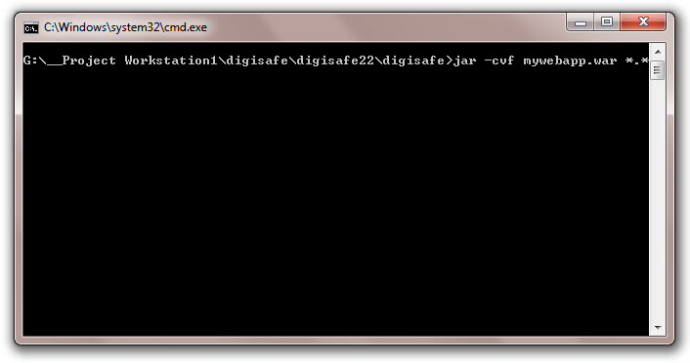

War File Made…

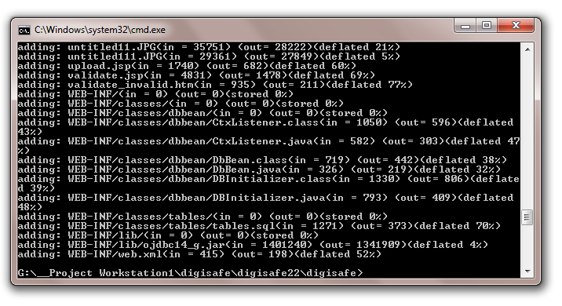

STEP 2:

AFTER INSTALLING ORACLE WEBLOGIC SERVER 10.X, START THE COFIGURATION WIZARD

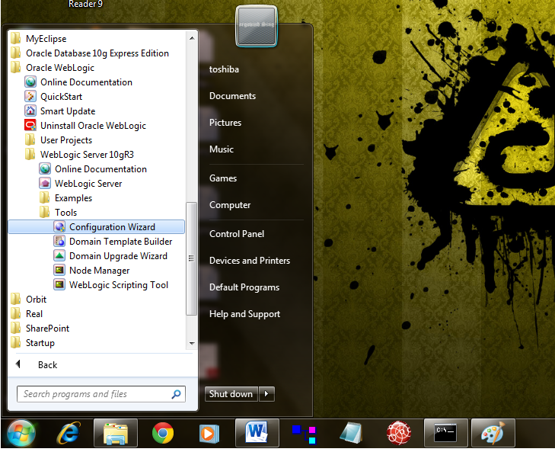

STEP 3:

CREATE A CUSTOM DOMAIN

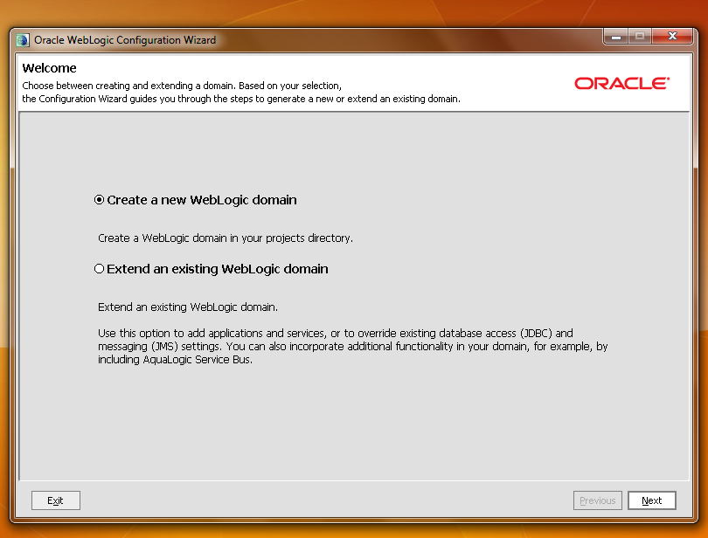

JUST DO NEXT> NEXT DON’T ALTER THE ALREADY SETTED CONFIGURATIONS.. ALSO JUST ENTER “WEBLOGIC” AS USERNAME AND PASSWORD WHILE CREATING THE DOMAIN

STEP 4:

START YOUR CUSTOM WEBLOGIC DOMAIN SERVER

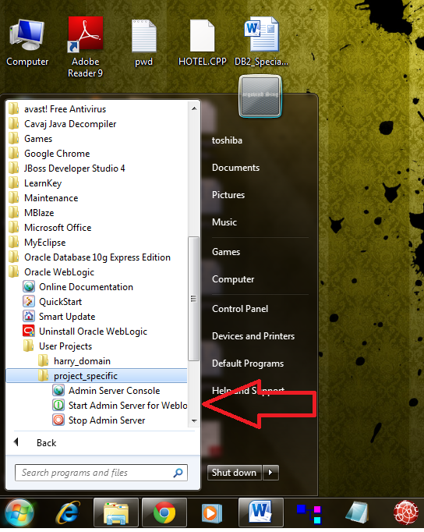

SERVER’S SERVICES GETTING STARTED …

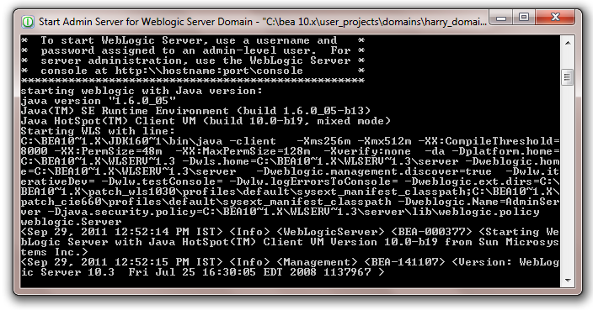

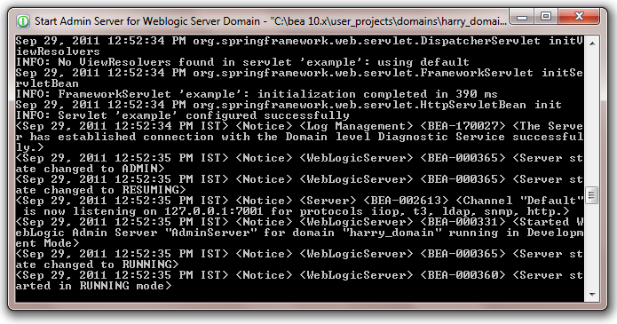

STEP 5:

GO TO YOUR LOCAL SEVER’S CONSOLE

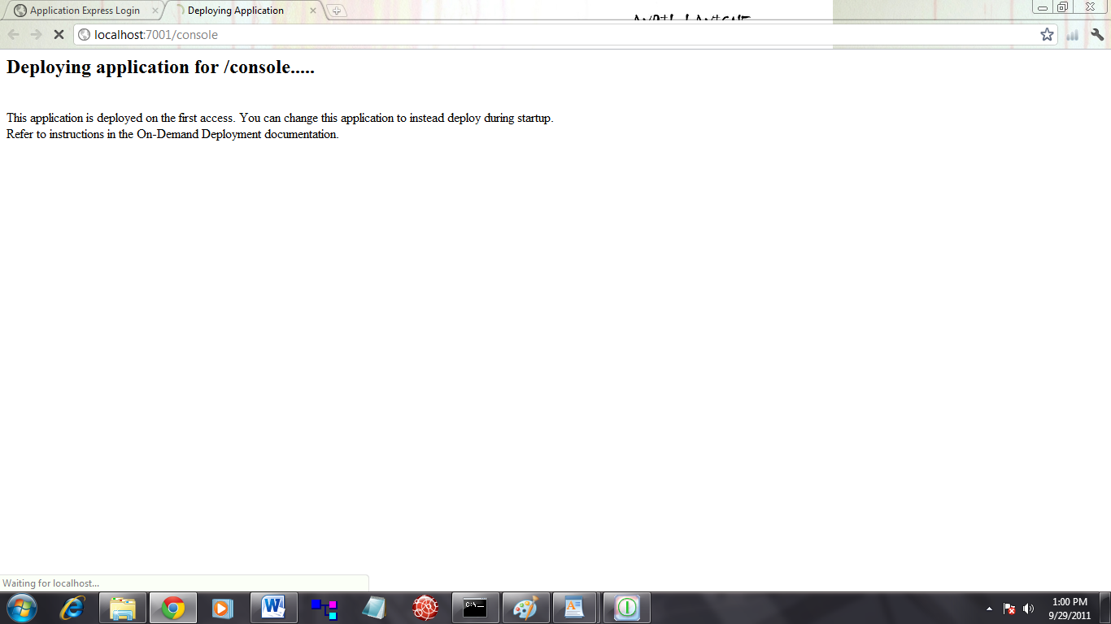

STEP 6:

ENTER THE CREDENTIALS YOU FILLED IN WHILE CRATING YOUR CUSTOM DOMAIN

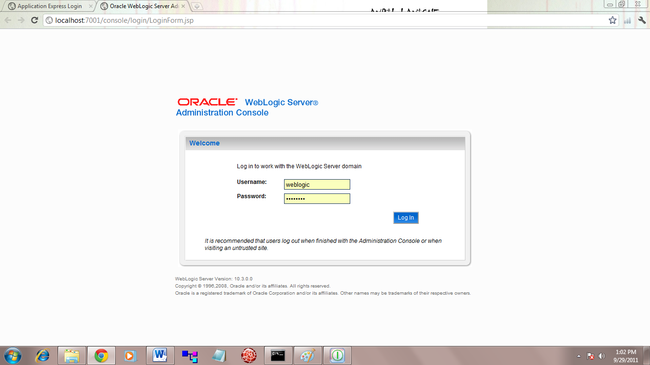

STEP 7:

LOGIN INTO DEPLOYMENTS SECTION

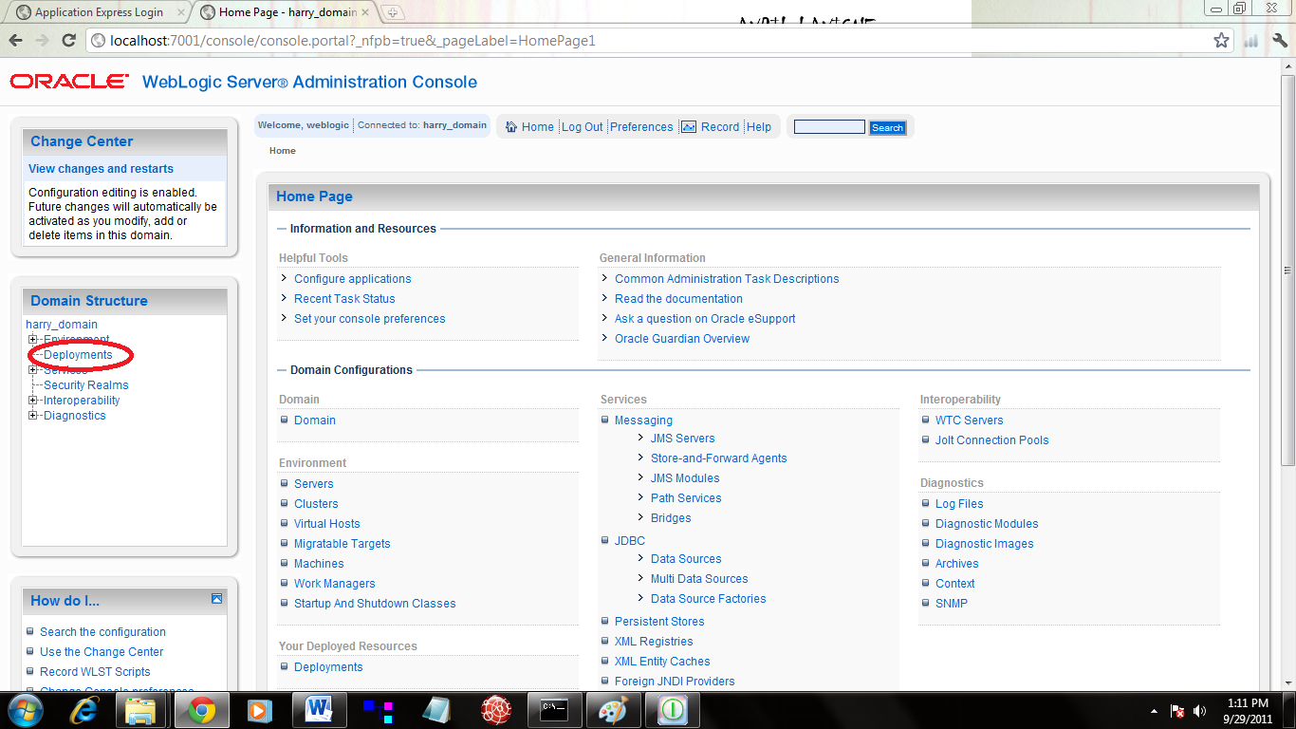

STEP 8:

TO DEPLOY YOUR WEB-APP, GO TO INSTALL

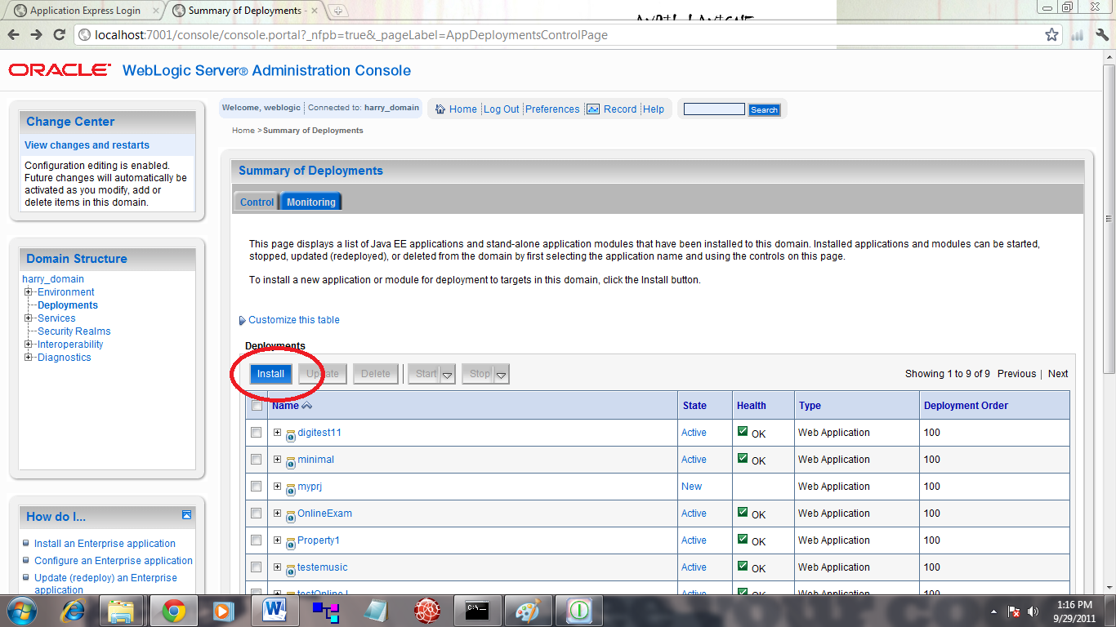

STEP 9:

1. GIVE THE DIRECTORY PATH
2. SELECT YOUR WEB-APP

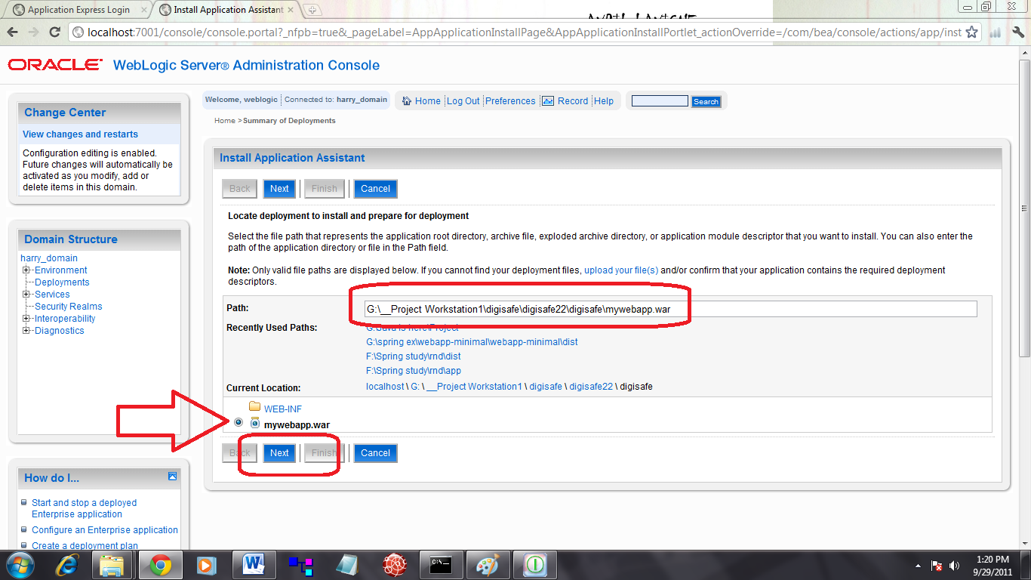

STEP 10:

1. INSTALL/DEPLOY YOUR WEB-APP AS AN APPLICATION

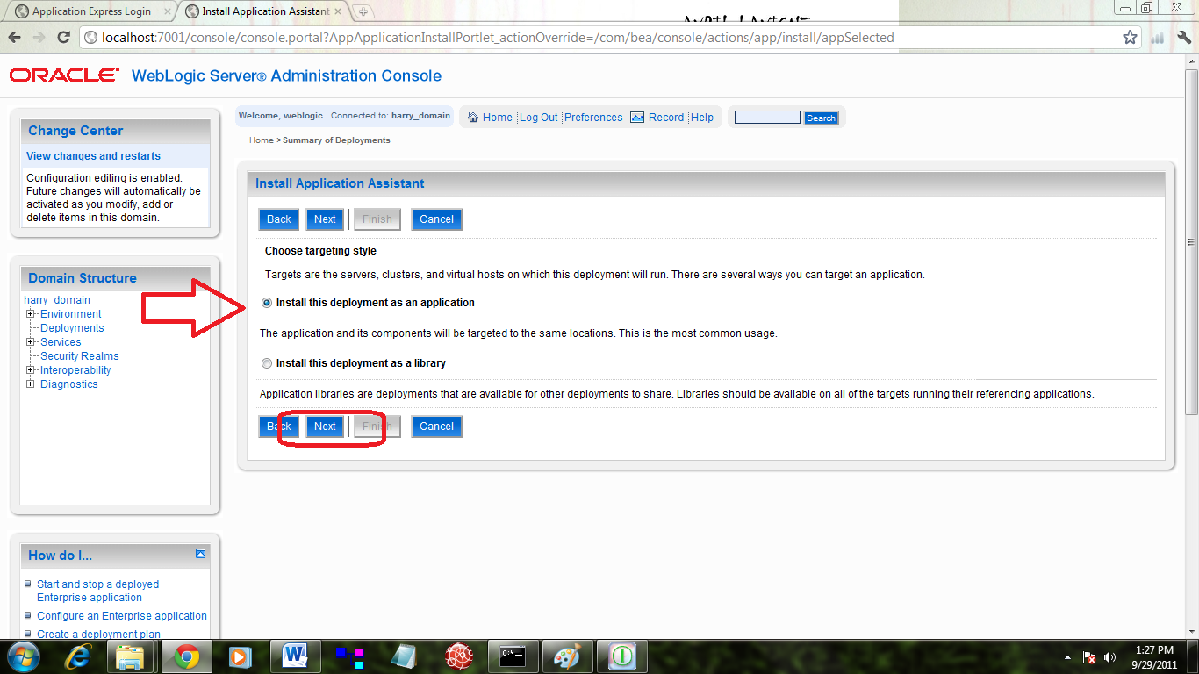

STEP 11:

1. CHANGE THE DEPLOYMENT FILE NAME IF NEEDED, ELSE LET IT BE AS IT IS.
2. FINISH THE INSTALLATION
3. GO TO DEPLOTMENTS’ CONFIGURATION SCREEN

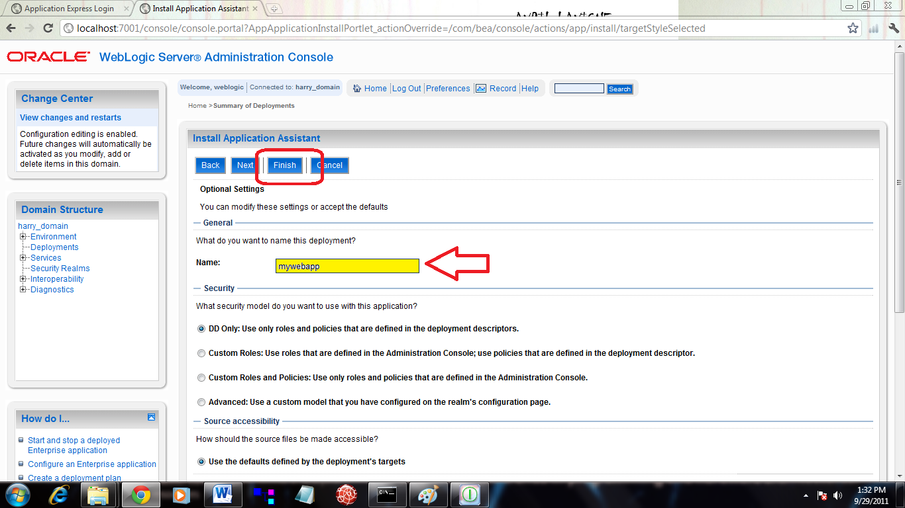

STEP 12:

GO TO TESTING SECTION OF THE WEB-APP CONFIGURATION SCREEN

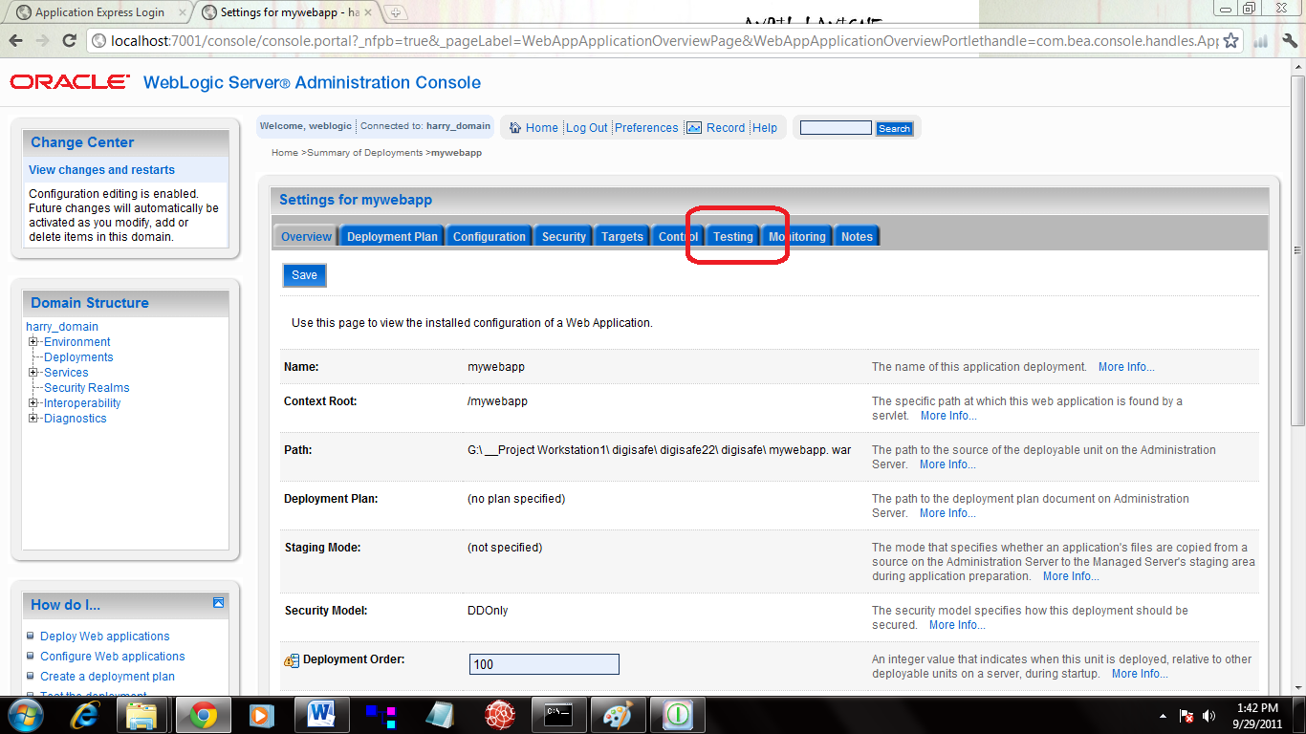

STEP 13:

1. DEPLOYMENT IS SUCCESSFULL
2. NOW, CLICK THE URL-PATTERN YOU SETTED TO LAUNCH YOUR APP

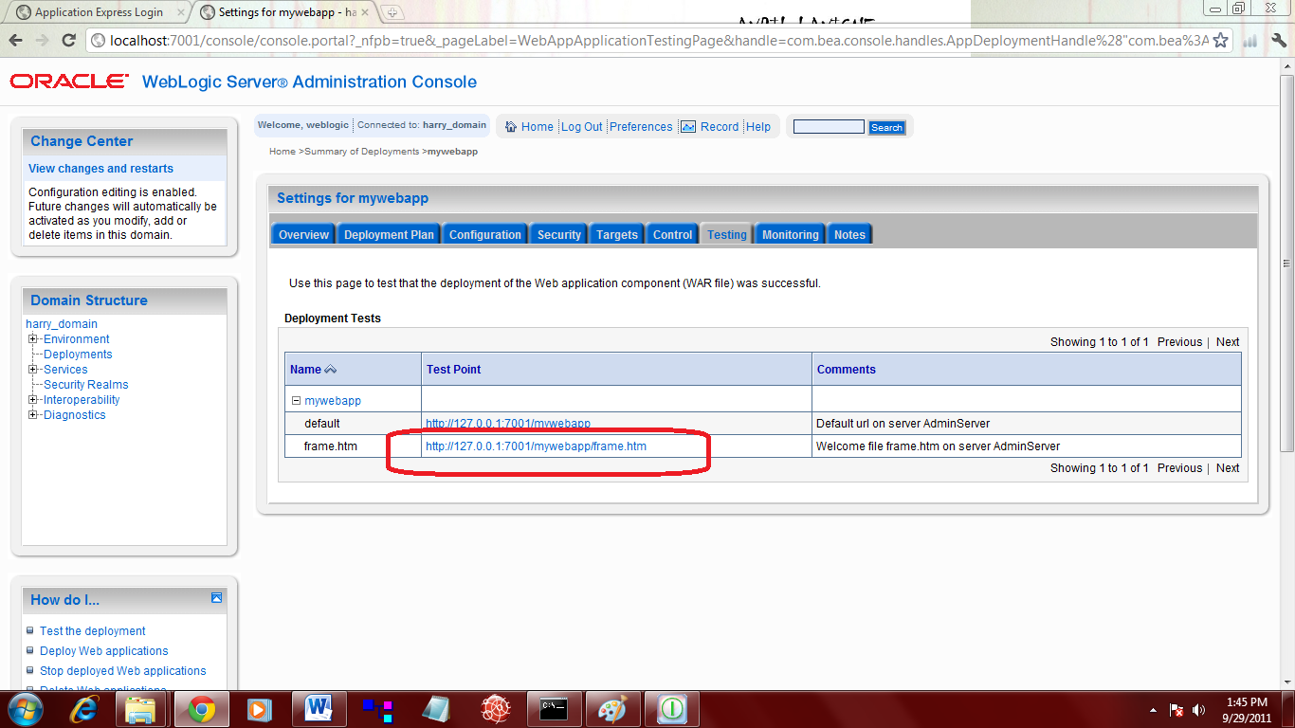

STEP 14:

YOUR WEB-APP HAS NOW LAUNCHED…

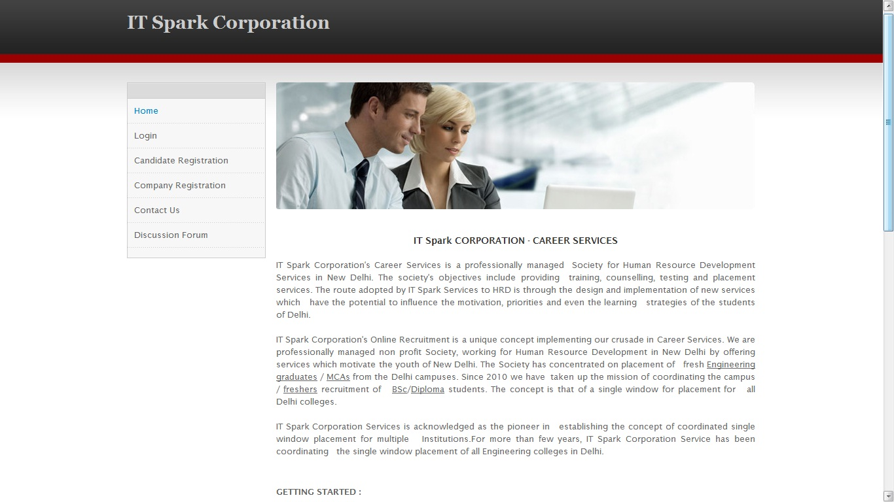

## WEBAPP OUTPUT:



